Curriculum Map: Statistics Year 9
 | Autumn 1 | Autumn 2 | Spring 1 | Spring 2 | Summer 1 | Summer 2
Content  Declarative knowledge  ‘I Know’ | Hypotheses and SEC  Statistical Enquiry Cycle (SEC)  - The steps required to carry out a sound statistical investigation  Forming hypotheses  - What a hypothesis is and how it might be tested  Different types of data  - The different types of data that arise  - Investigate situations when these types arise  - That a clear knowledge of the data type is key to understanding how to correctly interrogate the data (e.g. which diagram to use)  - The potential dangers of using secondary data  Questionnaires and  Experiments  - The different types of experiments and observation including the implications for level of control  - The difference between a census and a sample, possibly referencing the National Census as an example  - The terms ‘explanatory’, ‘response’ and ‘dependent’/ ‘independent’ (through use of examples) | Sampling  What a population is in different circumstances  The use of sample frames and sampling in general  Random sampling  - The concept of random sampling and how to carry it out using the different methods listed in the specification  Stratified sampling  - The concept of stratification and the necessary calculations and rounding issues that may arise  Systematic sampling  - The concept of and how to carry out a systematic sample  Convenience sampling  - The reasons for use of and dangers of convenience sampling  Quota sampling  - The concept of and how to carry out a quota sample  Extraneous variables | Representing Data 1  What it means to tally and tabulate data  - Also the implications of merging classes for continuous data  Pictograms  - Their features and use/misuse  Pie Charts and Comparative Pie Charts  - Their features  Stem and leaf diagrams  - Their features and the importance of a key in a stem-and-leaf diagram  Venn diagrams  - Their features | Representing Data 2  Choropleth maps  - Their features  Population pyramids  - Their features  Bar and line graphs  - Their features  Frequency polygons  - Their features  Histograms  - The features of a histogram with equal width classes  Scatter graphs  - Their features | Averages  Mean, mode and median  - The basic measures of average and their strengths and weaknesses  - That the mean can be calculated from a frequency table for specific values  - That the mean can be estimated from a frequency table of grouped data and why it is an estimate  - That a geometric mean can be calculated and the circumstances in which this is a better measure than the arithmetic mean  - That the median can be estimated for grouped data  - The concept of a weighted mean  Symmetry and Skew  - The basic concept of a symmetric distribution and of skew by inspection | Range and Spread  Range, Quartiles and Interquartile range  - The concept of measures of spread and the most basic of those, the range  - What quartiles are from a list of values and the concept of inter-quartile range  - What box plots display  Deciles and percentiles  - What deciles and percentiles are and the concept of inter-percentile and inter-decile ranges  Cumulative frequency  - The concept  Standard deviation  - The concept and what it is measuring  Outliers  - The concept of outliers and looking for them by inspection  - An understanding of outliers for the mean and standard deviation method
Skills  Procedural Knowledge  ‘I know how to’ | Hypotheses and SEC  - How to write and evaluate a questionnaire, including considerations in B4, avoiding bias and dealing with sensitive issues | Sampling  - How to deal with issues that arise with collected data including data collected from the internet  - How to identify and control extraneous variables  - How to carry out random sampling using the different methods listed in the specification | Representing Data 1  - How to tally and tabulate data including the use of different labelling systems  - How to draw a standard pie chart  - How to interpret pie charts already drawn  - How to construct a comparative pie chart for two data sets  - How to interpret and work with comparative pie charts and other 3D visualisation methods (e.g. from the media)  - How to draw a stem-and-leaf diagram, including a key  - How to draw a back-to-back stem-and-leaf diagram, including a key  - How to interpret stem-and-leaf and back-to-back stem-and-leaf diagrams  - How to draw Venn diagrams from information given  - How to interpret Venn diagrams (excluding their use for probability which comes later as a refresher for these diagrams) | Representing Data 2  - How to interpret choropleth maps  - How to interpret and compare data sets shown in population pyramids  - How to interpret and draw a basic bar char and bar line chart  - How to draw and interpret dual and composite bar charts  - How to draw and interpret percentage bar charts  - How to draw and interpret a frequency polygon  - How to construct and interpret a histogram with equal width classes  - How to draw and interpret a scatter graph (basic) | Averages  - How to find the mode or modal group and how to compare two data sets through the comparison of their modes (in context)  - How to calculate the mean for a set of data and from a frequency distribution for discrete data  - How to calculate an estimate of the mean for a grouped frequency distribution  - Comparing two data sets through the comparison of their means (in context)  - How to calculate a geometric mean  - How to calculate the median for a set of data and how to compare two data sets through the comparison of their medians (in context)  - How to identify the median for tabulated discrete data  - How to estimate the median for a grouped frequency distribution (calculation methods)  - How to calculate a weighted mean  - How to calculate skew from a given formula  - How to interpret the skewness of a distribution or compare the skewness of two distributions from inspection or from calculation | Range and Spread  - How to find cumulative frequencies for a grouped or discrete frequency distribution  - How to construct a cumulative frequency graph for a grouped frequency distribution  - How to construct a cumulative frequency step polygon for a discrete frequency distribution  - How to obtain estimates of the median and inter-quartile range from different cumulative frequency graphs and comparing the results in context  - How to obtain estimates of inter-decile range and inter-percentile range from different cumulative frequency graphs and comparing the results in context  - How to calculate the standard deviation for a list of values  - How to calculate the standard deviation (and mean) using sigma notation and frequency tables  - How to construct a box plot with or without statistical outliers included (of the  LQ –1.5 x IQR and  UQ +1.5 x IQR type)  - How to comment on outliers with reference to the original data
Strategies  Conditional Knowledge  ‘I know when to’ | Hypotheses and SEC  - When undertaking an investigation, implement proactive strategies that might be necessary in order to avoid bias and/or deal appropriately with sensitive issues  - Accept or reject a hypothesis, based on the evidence presented  - Compare outcomes with predictions and understand how they can be used to identify possible bias in the design. | Sampling  - Apply different sampling techniques in different contexts  - Use a sample rather than the whole population, and why this may be more appropriate. | Representing Data 1  - Use different forms of data representation, including their advantages and disadvantages. | Representing Data 2  - When various types of diagram can and cannot be used in terms of the nature of the data to be visualised  - Which different types of data can be used in the different types of diagrams | Averages  - Use different averages in different situations  - Use the weighted mean in different contexts | Range and Spread  - Know when to use the IQR rather than the range, and why it is more appropriate in certain contexts  - Know when to use the standard deviation and how to interpret it in context.
Key Questions | 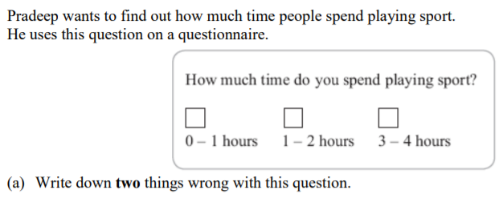 | 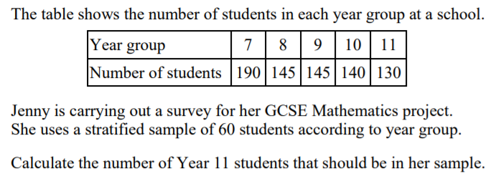 | 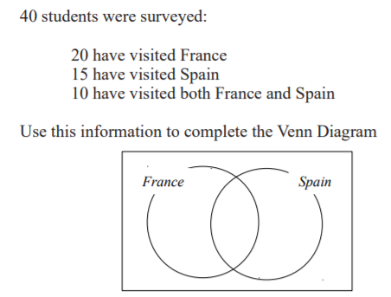 | 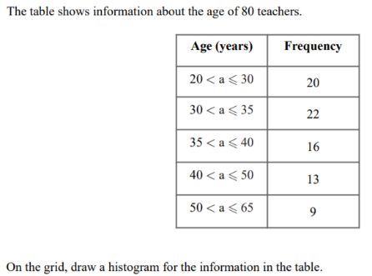 | 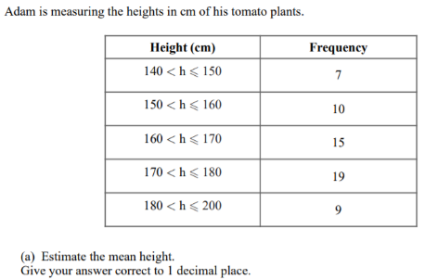 | 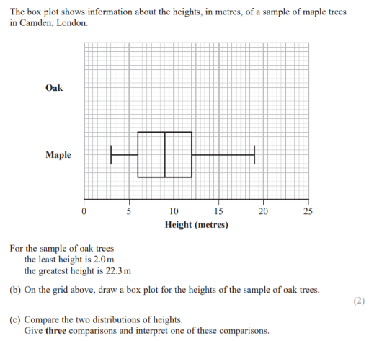
Assessment topics |  | Assessment covering all topics covered so far. |  |  | Assessment covering all topics covered so far.
Cross curricular links/  Character Education | Hypotheses and SEC  - Hypotheses are used in science subjects regularly, especially in Chemistry and Biology before an experiment is carried out. | Sampling  - Sampling techniques are used in a variety of subjects, including Biology and Psychology. | Representing Data 1  - Tallying and tabulating data can be seen across many different subjects such as the Sciences or Geography when collecting and analysing data. | Representing Data 2  - Choropleth maps are used regularly to show population density in Geography.  - Population pyramids are used in Geography to compare the distribution of ages in different countries. | Averages  - The geometric mean is used in Business and Economics to represent average annual growth.  - Averages are used across many subjects to compare different data sets. | Range and Spread  - The standard deviation is used in both Psychology and Biology to compare data sets.  - An understanding of outliers and how to interpret them is important in both Business and Economics.

