Curriculum Map: Further Mathematics Year 9
In addition to the content of Mathematics GCSE, learners should also be able to ….
 | Autumn 1 | Autumn 2 | Spring 1 | Spring 2 | Summer 1 | Summer 2
Content  Declarative knowledge  ‘I Know’ | Introduction to Computer Based Mathematical Tools  - Basic operations in GeoGebra and Computer Algebra Software such as WxMaxima | Matrices  - Multiplication of matrices  - Addition and subtraction of matrices  - The identity matrix | Functions  - Definition of a function  - Domain and range of a function.  - Composite functions | Functions  - Inverse functions  Quadratics  - Completing the square | Coordinate Geometry  - The definition of a gradient  - Know the relationship between the gradients of parallel and perpendicular lines.  - That Pythagoras’ theorem can be used to calculate the distance between two points  - The equation of a straight line as $y = mx + c$  and $y – y_{1} = m \left(x – x_{1}\right)$  and in other forms  - That a straight line can be drawn from various combinations of given information. | Differentiation  - That the gradient function $\frac{dy}{dx}$ gives the gradient of the curve and measures the rate of change of $y$ with respect to $x$.  - That the gradient of a function is the gradient of the tangent at that point.  - Differentiation of $kx^{n}$  where n is an integer and differentiation of  the sum of such functions  - The equation of a tangent and normal at any  point on a curve
Skills  Procedural Knowledge  ‘I know how to’ | Introduction to Computer Based Mathematical Tools  - Graph a function using GeoGebra  - Create a dynamic graph using sliders  - Use the spreadsheet in GeoGebra to plot points  - Use the drawing and measuring tools in GeoGebra  - Use CAS software to create a function and substitute values into that function  - Solve basic linear and quadratic equations using CAS software | Matrices  - Multiply a 2 x 2 matrix by a scalar  - Multiply a 2 x 2 matrix by a 2 X 1 matrix  - Multiply a 2 x 2 matrix by a 2 x 2 matrix  - Recognise the identity matrix | Functions  - Recognise and use function notation  - State the domain and range of a function  - On graph paper draw the graph of a function  - Combine functions | Functions  - Generate inverse functions  - Solve problems involving inverse functions  Quadratics  - Complete the square for the function $ax^{2}+bx+c$ where $a=1$  - Complete the square for the function $ax^{2}+bx+c$ where $a>1$  - Identify stationary points by completing the square | Coordinate Geometry  - Identify parallel and perpendicular lines.  - Work out the equation of a line given the gradient of a line parallel or perpendicular to it and at least one point which it passes through  - Calculate the distance between two points.  - Work out the coordinates of the midpoint of a line segment joining two points  - Recognise different forms for the equation of a straight line  - Find the coordinates of the point of intersection of two lines | Differentiation  - Differentiate positive and negative powers of a variable such as $x$  - Differentiate sums and differences of functions of $x$  - Differentiate functions of $x$ that first need expanding or dividing  - Use differentiation to work out the gradient of a curve  - Find the equation of a tangent or a normal to a curve
Strategies  Conditional Knowledge  ‘I know when to’ | Introduction to Computer Based Mathematical Tools  - Plot a graph using software and create variable aspects.  - Use a spreadsheet to plot large numbers of points.  - Use CAS software to set up formulae and substitute particular values into these  - Use CAS software to solve Equations. | Matrices  - To multiply a 2x2 matrix by a 2x1 matrix, each row of the 2x2 matrix is multiplied by the column of the 2x1 matrix.  - To multiply a 2x2 matrix by a 2x2 matrix, each row of the first 2x2 matrix is multiplied by each column of the second matrix.  - If two matrices are equal, the corresponding elements can be equated. | Functions  - A function maps an input, x, to an output $f(x)$  - The set of input values is the domain of $f(x)$  - The set of output values is the range of $f(x)$  - A composite function occurs when two or more functions act in succession. | Functions  - For any one-to-one function $f\left(x\right)$ there is an inverse function $f^{-1}(x$).  - The inverse of a function undoes the effect of the function.  - The graphs of a function and its inverse are reflections of each other in the line $y=x$ provided that the same scale is used on both axes.  Quadratics  - When factorising quadratics of the form $ax^{2} + bx + c$, find two numbers with $a$ sum of $b$ and product $ac$. Then split the coefficient of$x$ into these two numbers.  - When completing the square on a quadratic of the form $ax^{2} + bx + c$, take $a$ out as a factor, or divide both sides of the equation by $a$. | Coordinate Geometry  - Two lines are parallel when their gradients are equal.  - Two lines are perpendicular when the product of their gradients is -1.  - When the points A and B have coordinates ($x_{1},y_{1})$ and ($x_{2},y_{2})$ respectively, then  distance AB =  $$\sqrt{{\left(x_{2}-x_{1}\right)}^{2}+{\left(y_{2}-y_{1}\right)}^{2}}$$  and midpoint of AB is at  $$\left(\frac{x_{1}+x_{2}}{2},\frac{y_{1}+y_{2}}{2}\right)$$  - The coordinates of the point of intersection of two lines are found by solving their equations simultaneously. | Differentiation  Apply the results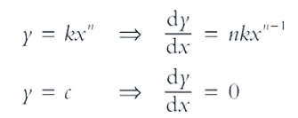  where n is a positive integer and k and c are constants.  $y=f(x)+g(x)$  ⇒ $\frac{dy}{dx}=f'(x)+g'(x)$  For the tangent and normal at $\left(x_{1},y_{1}\right)$  - the gradient $m_{1}$of the tangent is the value of $\frac{dy}{dx}$  - the gradient $m_{2}$of the normal is $\frac{-1}{m_{1}}$  - the equation of the tangent is  $y-y_{1} =m_{1} (x-x_{1})$  - the equation of the normal is  $y-y_{1} =m_{2} (x-x_{1})$
Examples  of  Key Questions | Introduction to Computer Based Mathematical Tools  Create the graph of  y= mx+c so the intercept and gradient can be varied:  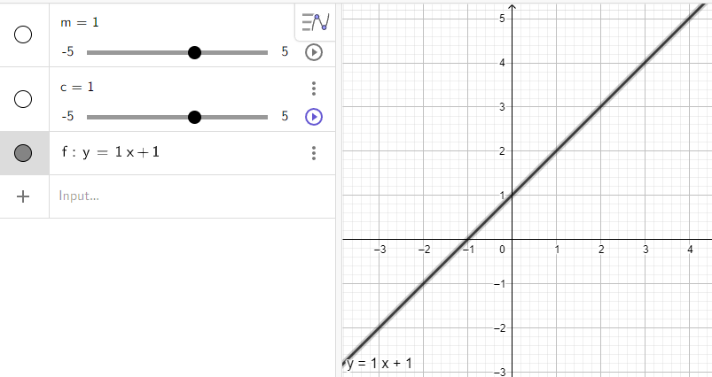  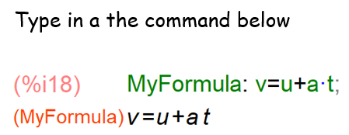  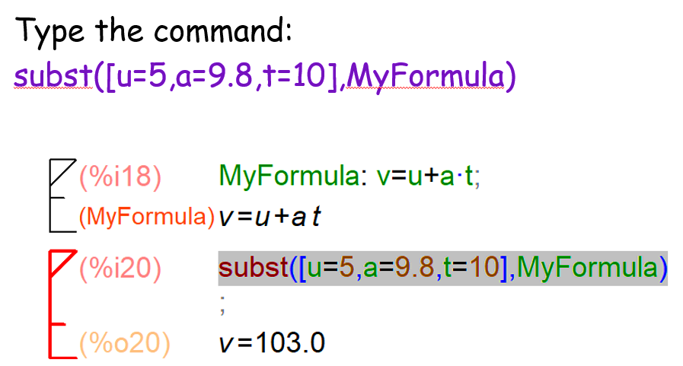 | Matrices  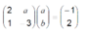  Work out all possible pairs of values a and b.  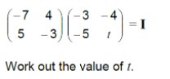 | Functions  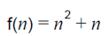    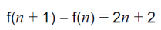  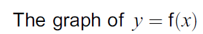  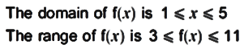  If $f(x) = x - 1$ and $g(x) = 5x + 2$, then find $f(g(2))$ | Functions  Given that  $f\left(x\right)={\left(x-2\right)}^{3}+1$,  find $f^{-1}(x)$.  Quadratics  Determine the values of a, b and c such that: | Coordinate Geometry  We are given that  $A is at \left(-3, -4\right)$  and  $$B is at (4, 3)$$  For this straight line segment, AB, work out  - the mid-point of $AB$  - the gradient of $AB$  - the length of $AB$, giving your answer as an integer or a surd | Differentiation  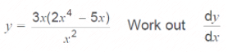  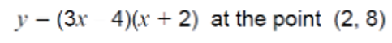  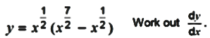        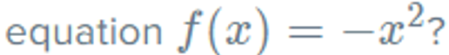  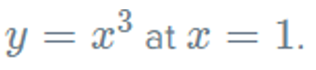
Assessment topics | Online homework tasks | Assessed in end of term testing | Assessed in end of term testing | Assessed in end of term testing | Assessed in end of year testing | Assessed in end of year testing
Cross curricular links/  Character Education | Introduction to Computer Based Mathematical Tools  Computer Science and IT Function syntax and logic, concept of a variable in programming, notion of an array  Sciences  Use of computer graphing programs to plot experimental data | Matrices  Computer Science and IT  2-dimensional arrays | Functions  Computer Science  Concepts and notation used in programming. | Functions  Computer Science  Concepts used in programming instructions  Science  Changing the subject of a formula for calculation in Physics and Chemistry | Coordinate Geometry  Physics and Chemistry Equations of straight lines for empirical data  Computer Science  Use of distance metrics in programming | Differentiation  Physics  Links to rate of change in kinematics  Chemistry  Rates of change in reactions.  Economics  Financial models and rates of change

