Curriculum Map: Further Mathematics Year 11
In addition to the content of GCSE Mathematics, learners should also be able to ….
 | Autumn 1 | Autumn 2 | Spring 1 | Spring 2 | Summer 1 | Summer 2
Content  Declarative knowledge  ‘I Know’ | Circles  - The equation of a circle with centre (h, k) and radius $r$ is  $${\left(x-h\right)}^{2} +{\left(y-k\right)}^{2}=r^{2}$$  - When the centre is at the origin $(0, 0)$ this simplifies to ${ x}^{2}+y^{2}=r^{2}$  - Equations of tangents to circles  - Recall circle theorems and their proofs  Further Algebra  - Factorising more difficult expressions with 2 variables  - Index Laws  - Rational Expressions  - Factor Theorem  - Algebraic proof | Sequences  - The nth term of a quadratic sequence  - Sequences with nth terms of the form $\frac{an+b}{cn+d}$  Inequalities  - Solutions of linear and quadratic inequalities  PPE Preparation  Revision of all material for Nov/Dec PPE | Trigonometry and Pythagoras’ Theorem  - Sine, cosine and area rules for non-right-angled triangles  - Pythagoras’ Theorem in two and three dimensions  - Exact trigonometric values  - Trigonometric identities  - Understanding the graphs of the sine, cosine and tangent functions | Trigonometry and Pythagoras (continued)  - Know the values of sine, cosine and tangent for $0°, 30°,45°, 60°$and $90°$  - Know the trigonometric identities  $$sin^{2} x + cos^{2} x ≡1$$  $$\frac{sin x }{cos x}≡\tan{x}$$  - Understanding the graphs of the sine, cosine and tangent functions  - Solving trigonometric equations  PPE Preparation  Revision of all material for March PPE | Final Exam preparation  Revision of all material for final exams | Final Exam preparation and Exams  Revision for final exams and sitting of exams
Skills  Procedural Knowledge  ‘I know how to’ | Circles  - Recognise the equation of a circle  - Write the equation of a circle given the radius and the coordinates of the centre  - Solve a variety of problems involving tangents to circles  - Use and prove key circle theorems:  - The angle in a semi-circle is 90°.  - The perpendicular from the centre of a circle to a chord bisects the chord.  - The angle between tangent and radius is 90°.  Further Algebra  - Factorise an algebraic expression using no more than two brackets  - Rearrange a formula to make a different letter the subject when the new subject occurs once  - Simplify algebraic fractions connected by any of the symbols $+, -, × or ÷$  - Solve linear equations containing algebraic fractions | Sequences  - Find and use the nth term of linear and quadratic sequences  - Find the limiting value of a sequence of the form $\frac{an+b}{cn+d}$  Inequalities  - Solve linear and quadratic inequalities | Trigonometry and Pythagoras’ Theorem  - Calculate the area of a triangle, given two sides and an included angle  - Use the sine rule and/or cosine rule to calculate unknown angles and sides  - Draw a 2-D representation of a 3-D object  - Calculate the angle between a line and a plane or the angle between two planes  - Use Pythagoras' theorem to calculate lengths in three dimensions  - Solve practical problems in three dimensions using the knowledge above  - Sketch and recognise the graphs of sine, cosine or tangent for any angle | Trigonometry and Pythagoras (continued)  - Use the values of sine, cosine and tangent for $0°, 30°,45°, 60°$and $90°$.  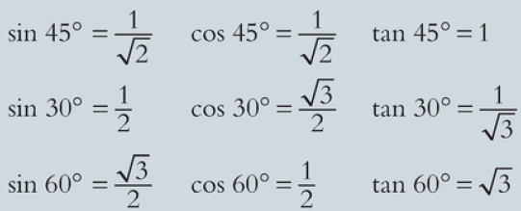  - Recognise and use the trigonometric identities linking sine, cosine and tangent  - Solve trigonometric equations | See all previous sections | See all previous sections
Strategies  Conditional Knowledge  ‘I know when to’ | Circles  - Select as appropriate  $${\left(x-h\right)}^{2} +{\left(y-k\right)}^{2}=r^{2}$$  or $x^{2}+y^{2}=r^{2}$  for the equation of a circle.  Apply these circle facts to solve problems:  - the angle in a semi-circle is $90°$  - the perpendicular from the centre of a circle to a chord bisects the chord  - the angle between tangent and radius is $90°$  - the tangents to a circle from an external point are equal in length  Further Algebra  - When changing the subject of a formula, the new subject should be on its own on the left-hand side.  - When simplifying an algebraic fraction involving addition or subtraction, first find a common denominator.  - When solving an equation involving fractions, start by multiplying through by the least common multiple of all the denominators to eliminate the fractions. | Sequences  - Select as appropriate an nth term of the form  $an + b$  or an nth term of the form  $an^{2} + bn + c$.  - A sequence with an nth term of the form $\frac{an + b}{cn+d}$has a limit of $\frac{a}{c}$ as $n$ approaches infinity.  Inequalities  - Deal correctly with signs if the inequality is multiplied (or divided) throughout by a negative value  - When solving a quadratic inequality, first take all terms to one side. | Trigonometry and Pythagoras’ Theorem  - For the area of a triangle  $$Area = ½ ab sin C$$  - The Sine Rule  $$\frac{a}{Sin A}=\frac{b}{Sin B}=\frac{c}{\sin{}C}$$  - The Cosine Rule  $$a^{2}=b^{2}+c^{2} -2bc cosA$$  When solving three-dimensional problems, always draw a clear diagram where  - vertical lines are drawn vertically  - east-west lines are drawn horizontally  - north-south lines are drawn sloping  - edges that are hidden are shown as dotted lines  - In three dimensions, Pythagoras’ theorem extends to  $$a^{2}+b^{2} +c^{2} =d^{2}$$ | Trigonometry and Pythagoras (continued)  - Apply exact trigonometric values.  - Use trigonometric identities to simplify expressions and to solve equations.  - Solve trigonometric equations for an initial value using a calculator and then find other values in given range by using a trigonometric graph. | See all previous sections | See all previous sections
Examples of  Key Questions | Circles  Write down the centre and radius of the circle with equation  $$x^{2}+{\left(y+3\right)}^{2}=25$$  A circle has a centre C and passes through points A$(-2,1)$ and $B(4, 2)$. Work out the equation of the line that is perpendicular to AB and passes through C.  Further Algebra  Factorise $3x^{2}-10xy-8y^{2}$  Make $x$ the subject of $y=\frac{x+1}{2+x}$ | Sequences  As $n→∞$, find the limiting value of the sequence with nth term  $$\frac{2-6n}{5-2n}$$  Inequalities  Solve  $$x^{2}-2x-3>0$$  Solve  $$\frac{5-3x}{3}<5$$ | Trigonometry and Pythagoras’  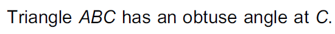  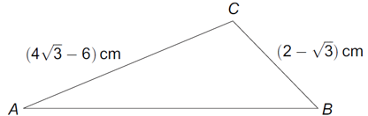  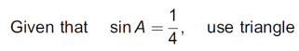  A square based pyramid, ABCDE, is shown below.  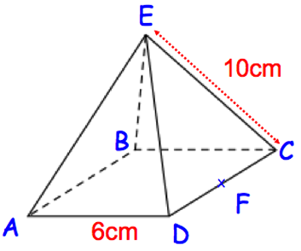  F is the midpoint of CD.  AD = 6cm and CE = 10cm  Calculate the lengths of BD and EF. | Trigonometry and Pythagoras (continued)  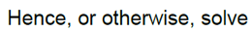  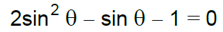  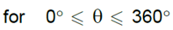  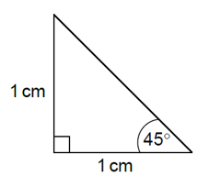  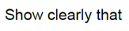  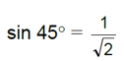 | See all previous sections | See all previous sections
Assessment topics | Assessed in the Nov/Dec PPE | Assessed in the Nov/Dec PPE | Assessed in the March PPE | Assessed in the March PPE | Assessed in the final GCSE exams | Assessed in the final GCSE exams
Cross curricular links/  Character Education | Art  Use of geometry in Art, for instance in the works of Picasso and Braque  Science  Circular motion in Physics. | Business Studies  Limiting values of sequences used in loan and repayment schedules.  Science  Quadratic inequalities in projectile motion. | Science  Periodic phenomenon in Biology, Chemistry and Physics.  Design  Calculations of length, areas and volumes in design and construction. | Science  Solution of equations involving periodic phenomena. | See all previous sections | See all previous sections

