Curriculum Map: Further Mathematics Year 10
In addition to the content of GCSE Mathematics, learners should also be able to ….
 | Autumn 1 | Autumn 2 | Spring 1 | Spring 2 | Summer 1 | Summer 2
Content  Declarative knowledge  ‘I Know’ | Number System: Fractions, Decimals, Percentages and Ratio  - Knowledge and use of numbers and the number system including fractions, decimals, percentages, ratio, proportion and order of operations are expected.  Manipulating Algebra  - Expand brackets and collect like terms  - Expand ${(a+b)}^{n}$ for any positive integer n.  - An expansion of $(a + b)"$ comprises $n + 1$terms, each of the form $Pa^{q}b^{r}$ where P is a number from Pascal's triangle and  $q + r = n$. | Surds  - Manipulating surds including rationalising the denominator.  Product Rule for Counting  - Use of the product rule in combinations and permutations problems. | Differentiation  - A function is decreasing if $\frac{d^{2}y}{dx^{2}}<0$  - A function is increasing if $\frac{d^{2}y}{dx^{2}}>0$  - The second derivative is obtained by differentiating $\frac{dy}{dx}$ and is denoted by $\frac{d^{2}y}{dx^{2}}$  - At a stationary point at $\frac{dy}{dx}=0$ | Matrices  - Transformations of the unit square in the x–y plane  - Combination of transformations  - A transformation of matrix $A$ followed by a transformation of $B$ is a combined transformation with matrix $BA$.  - A point P$(x. y)$ can be transformed to an image point $P’(x’, y’).$  If the transformation matrix is $\left(\begin{matrix}a & b \\ c & d\end{matrix}\right)$,  then $\left(\begin{matrix}a & b \\ c & d\end{matrix}\right)\left(\begin{aligned}x \\ y\end{aligned}\right)=\left(\begin{aligned}x' \\ y'\end{aligned}\right)$  - $I$ is the identity matrix $\left(\begin{matrix}1 & 0 \\ 0 & 1\end{matrix}\right)$  Coordinate Geometry  - Use ratio to find the coordinates of a point on a line given the coordinates of two other points.  - Understand that  $x^{2} + y^{2} = r^{2}$ is the equation of a circle with centre $(0, 0)$ and radius $r$ | Linear and Non-Linear Functions  - Drawing and sketching of functions.  - Interpretation of graphs. | Solving Equations  - Solution of linear and quadratic equations.  - Algebraic and graphical solution of simultaneous equations in two unknowns, where the equations could both be linear or one linear and one quadratic.  - Algebraic solution of linear equations in three unknowns
Skills  Procedural Knowledge  ‘I know how to’ | Number System: Fractions, Decimals, Percentages and Ratio  - Perform arithmetic operations with fractions, decimals and percentages.  - Solve problems involving ratio and proportion.  Manipulating Algebra  - Work out the product of two [or more] algebraic expressions  - Work out the expansion of an expression of the form $(a + b)"$, where n is a positive integer | Surds  Manipulate expressions involving surds, including  - simplifying surds  - adding/subtracting compatible surds  - rationalising a denominator of the form $\sqrt{a}$  - rationalising a denominator of the form $a + \sqrt{b}$  Product Rule for Counting  - Efficiently find the number of combinations, given a particular condition. | Differentiation  - Use differentiation to identify stationary points on a polynomial curve.  - Use the second derivative to determine the nature of any stationary points.  - Identify when a function is increasing and when it is decreasing.  - Sketch polynomial functions using information from the first and second derivatives  - Understand and use the notation $\frac{d^{2}y}{dx^{2}}$  - Use of differentiation to find maxima and minima on a curve and in simple problems  - Sketch/ interpret a curve with known maximum and minimum points | Matrices  Recognise and use the following transformations when written as matrices:  - reflection in the x-axis  - reflection in the y-axis  - reflection in the line y = x  - reflection in the line y = - x  - rotation of 90° about the origin  - rotation of 180° about the origin  - rotation of 270° about the origin  - enlargement of scale factor …, centre the origin  - Apply a combination of transformations  - Work out the matrix which represents a combination of transformations.  Coordinate Geometry  - Divide a straight line segment in a given ratio.  - Recognise the equation of a circle.  - Given the radius, write down the equation of a circle, centred at the origin. | Linear and Non-Linear Functions  - Draw the graph of a function on graph paper.  - Sketch a graph - not using graph paper.  - Find the equation of a line given either the coordinates of two points on the line or the gradient of the line and the coordinates of one point.  - Recognise the shape of a quadratic graph from its equation, determining whether it has a maximum or minimum turning point.  - Recognise the graphs of the basic exponential functions $y = a^{x}$ and  $y ={ a}^{-x}$ and functions associated with them | Solving Equations  - Solve problems involving ratio and proportion.  - Solve quadratic equations  - by factorising  - by completing the square  - by using the quadratic formula  - by drawing a graph  - Solve simultaneous equations in 2 or 3 unknowns by plotting their graphs
Strategies  Conditional Knowledge  ‘I know when to’ | Number System: Fractions, Decimals, Percentages and Ratio  - Convert mixed numbers to improper numbers before or after arithmetic operations  - Simplify ratios, including mixed units  - Share in a given ratio  - Solve problems involving percentage change  - Solve problems involving combinations of percentages, ratios and fractions.  Manipulating Algebra (1)  - Simplify algebraic expressions by collecting like terms and/or expanding brackets.  - Add/subtract algebraic expressions by rewriting with common denominators.  - Simplify fractions by cancelling common factors in the numerator and denominator. | Surds  - When simplifying surds:  - only like surds can be added or subtracted.  - $\sqrt{a}×\sqrt{b}=\sqrt{ab}$  - A denominator can be rationalised as follows:  (i)$\sqrt{a}$can be rationalised by using the multiplier $\sqrt{a}$;  (ii)$a + \sqrt{b}$can be rationalised by using the multiplier $a - \sqrt{b}$;  (iii) a two-term expression can be rationalised using a multiplier found by changing one sign  Product Rule for Counting  - When applying the product rule of counting, consider the number of options as each item is selected, and multiply them to find the number of possibilities. | Differentiation  - The nature of the stationary point can be determined by looking at the sign of the gradient just either side of it:  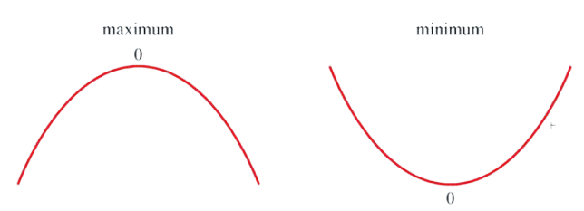  - The sign of $\frac{d^{2}y}{dx^{2}}$ is an alternative way of determining the nature of the stationary point. | Matrices  - Apply a combination of transformations, including consideration of the appropriate order  Coordinate Geometry  - If C divides line AB in the ratio p: q where A is ($x_{1},y_{1})$ and B is ($x_{2},y_{2})$, then C is at  $$\left(\frac{px_{1}+qx_{2}}{p+q},\frac{{py}_{1}+qy_{2}}{p+q}\right)$$  - The equation of a circle with centre (h, k) and radius r is  $${(x-h)}^{2}+{(y-k)}^{2}=r^{2}$$  When the centre is at the origin (0, 0), this simplifies to:  $$x^{2}+y^{2}=r^{2}$$ | Linear and Non-Linear Functions  - Use or not use graph paper (draw v sketch)  - The gradient of the straight line joining the points $(x_{1},y_{1})$ and $(x_{2},y_{2})$ is given by:  $$\frac{y_{2}-y_{1}}{x_{2}-x_{1}}$$  - The equation of a straight line may take any of these forms:  - Line parallel to the $y$ axis: $x = a$  - Line parallel to the $x$-axis: $y=b$  - Line through the origin with gradient m: $y = mx$  - Line through $(0, c)$ with gradient $m$ : $y= mx + c$  - Line through ($x_{1},y_{1})$ with gradient m:  $$y-y_{1}=m(x-x_{1})$$  - Line through $(x_{1},y_{1})$ and ($x_{2},y_{2})$:  $$\frac{y-y_{1}}{y_{2}-y_{1}}=\frac{x-x_{1}}{x_{2}-x_{1}}$$  - The shape of a quadratic graph is a parabola. It may be either $∪$shaped (when the coefficient of the squared term is positive) or $∩$ shaped (when it is  negative).  - An exponential function is a function of the form $y = a^{x}$ or $y ={ a}^{-x}$ where $a>0$ | Solving Equations  - When factorising quadratics of the form $ax^{2}+ bx + c$, find two numbers  with a sum of b and product ac. Then split the coefficient of x into these two numbers.  - If  $ax^{2}+bx+c=0$ then $x\frac{=-b∓\sqrt{b^{2}-4ac}}{2a}$  - Use substitution, elimination, and graphing to solve simultaneous equations in 2 and 3 unknowns
Examples of Key Questions | Number System: Fractions, Decimals, Percentages and Ratio  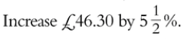  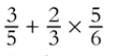  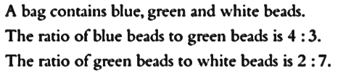  Manipulating Algebra  In the expansion of  ${(a+5x)}^{4}$ where $a$ > 0, the coefficient of $x$ is three times the coefficient of $x^{2}$ . Work out the value of $a$. | Surds  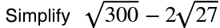  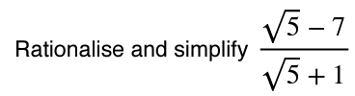  Product Rule for Counting  Orla picks a 5-digit odd number. The second digit is a third of the first digit. The third digit is less than 6. How many different numbers satisfy this description? | Differentiation  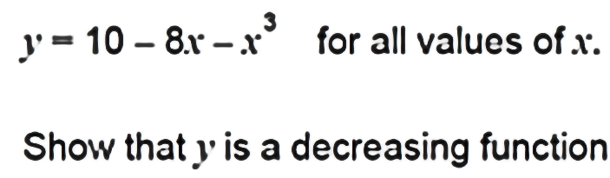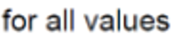  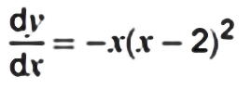    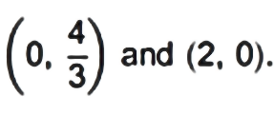  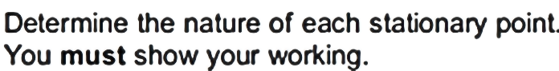 | Matrices  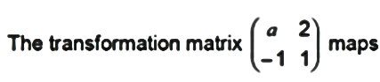  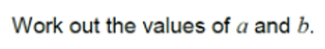  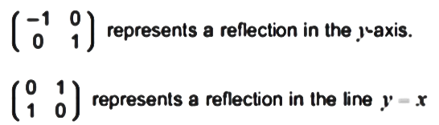  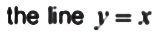  Coordinate Geometry  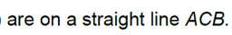  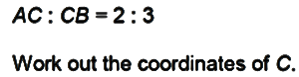  Write down the centre and radius of each of these circles.  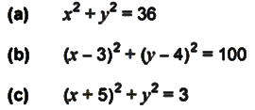 | Non-Linear Functions  Work out the equation of a line through point $(1,2)$ with gradient 2.  Sketch the equation  $x+3y-9=0$  Find the equation of the line joining $(-1,4)$ and $(2,-3)$  Sketch the graphs of  $2x^{2}+3x-1=y$ and $4x^{2}+7x-2=y$  On the same axes, plot the graphs of  $y=2^{x}$ and $y=2^{-x}$  for $-2≤x≤2$ | Solving Equations  By completing the square, solve the equation  $2x^{2}+3x-7=0$  Solve the three simultaneous equations  $3x+2y-3z=-13$, $2x-3y+4z=24$ and  $$4x-5y+2z=22$$  Solve $x^{2}+y^{2}=8$ and  $y-x=4$
Assessment topics | Assessed in end of term testing | Assessed in end of term testing | Assessed in end of term testing | Assessed in end of term testing | Assessed in end of year testing | Assessed in end of year testing
Cross curricular links/  Character Education | Number System  Sciences  Percentages errors in experiments.  Mixing quantities in given ratios  Food Technology  Scaling recipes  Business  Percentage profit and loss  Manipulating Algebra  Sciences/Business  Use and rearranging of formulae | Surds  Sciences  Use in intermediate level calculations to improve the accuracy of predictions  Product Rule for Counting  Biology  Combinatorics in genetics, in particular Mendelian Genetics | Differentiation  Physics  Stationary points in kinematics (e.g. for projectile motion)  Economics  Use of optimisation in financial problems. | Matrices  Physics  Understanding of invariance of physical laws under rotational transformations  Coordinate Geometry  Computer Science  Generation of circular graphics in programming | Non-Linear Functions  Sciences  Finding the equations of lines of best fit  Physical processes that following exponential growth or decay patterns | Solving Equations  Science  Understanding systems represented by a set of linear equations  Computer Science  Solutions of linear algebra by programmatically

