Curriculum Map: Mathematics Year 10 - Foundation
 | Autumn 1 | Autumn 2 | Spring 1 | Spring 2 | Summer 1 | Summer 2
Content  Declarative knowledge  ‘I Know’ | Indices and Standard Form  - Index notation.  - Estimating powers and roots.  - Laws of indices  - Writing numbers in standard form.  - Calculations with numbers in standard form.  Algebraic Manipulation  - Simplifying expressions.  - Expanding brackets.  - Factorising expressions.  - Completing the square.  - Substitution. | Algebraic Solutions of Equations  - Solving linear equation with one unknown.  - Solving quadratic equations.  Fractions and Decimals  - Simplifying and equivalent fractions.  - Fraction arithmetic.  - Algebraic fractions.  - Decimal arithmetic.  - Recurring decimals to fractions.  Data Collection and Sampling  - Populations and samples.  - Averages and range  - Construct charts for categorical data (frequency tables, bar charts, pie charts, pictograms).  - Construct charts for ungrouped numerical data (vertical line charts). | Congruent and Similar Shapes  - Identify congruent triangles.  - Identify similar triangles.  - Compare lengths, areas and volumes using scale factors.  Pythagoras  - Find missing sides in right angled triangles.  - Apply Pythagoras’ theorem in a 3D context.  Trigonometry  - Find missing sides and angles in right angled triangles.  - Use trigonometry  - Exact trigonometric values.  Proofs and Formulae  - Formulate algebraic expressions.  - Change the subject of the formula.  - Algebraic terminology and proofs. | Organising, Presenting and Analysing Data  - Time series graphs  - Cumulative frequency  - Box plots  Bivariate Data  - Scatter diagrams  - Correlation  - Lines of best fit  Accuracy and Bounds  - Upper and lower bounds.  - Error intervals.  - Problem solving with upper and lower bounds.  Mensuration  - Circumference and area of a circle  - Sector Area  - Arc Length | Simultaneous Equations  - Linear simultaneous equations.  - Quadratic simultaneous equations.  - Forming and solving simultaneous equations.  Percentage Change  - Compound and simple interest  - Exponential growth and decay  Bearings and Scale Drawings  - Measure and draw bearings.  - Calculate bearings.  - Construct and interpret scale drawings. | Prisms  - Volume of prisms  - Surface area of prisms  Probability  - Relative frequency  - Sample spaces  - Enumeration  - Venn diagrams  - Probability trees  Constructions and Loci  - Perpendicular and angle bisector.  - Perpendicular from a point to a line.  - Identify the loci of points.  2D and 3D Representation  - Plans and elevations.  - Properties of 3D shapes.
Skills  Procedural Knowledge  ‘I know how to’ | Indices and Standard Form  - Write numbers using index notation.  - Use negative indices to represent reciprocals.  - Use fractional indices to represent roots.  - Estimate powers and roots.  - Apply the rules of indices.  - Interpret and order numbers expressed in standard form.  - Convert numbers to and from standard form.  - Use a calculator to perform calculations with numbers in standard form.  - Add, subtract, multiply and divide numbers in standard form without a calculator.  Algebraic Manipulation  - Simplify algebraic expressions by expanding a simple bracket.  - Expand products of two binomials.  - Factorise by taking out common factors  - Factorise quadratic expressions where the coefficient of x² is 1.  - Substitute positive or negative numbers into simple and complex formulae. | Algebraic Solutions of Equations  - Solve linear equations in one unknown.  - Solve linear equations with the unknown on both sides (including with brackets and fractions).  - Set up and solve linear equations in mathematical and non-mathematical contexts.  - Solve quadratic equations through factorising.  Fractions and Decimals  - Recognise and use equivalence between fractions and mixed numbers.  - Add, subtract, multiply and divide simple fractions including mixed numbers and negative fractions.  - Calculate a fraction of a quantity including with fractions greater than 1.  - Express a simple fraction as a terminating decimal or vice versa.  - Use division to convert a simple fraction to a decimal.  - Add, subtract and multiply decimals including decimals that are negative.  - Divide a decimal by a whole number and another decimal without using a calculator.  Averages and Charts  - Calculate the mean, mode, median and range from ungrouped data.  - Calculate estimates of mean, mode and range from grouped data.  - Interpret and construct frequency tables, bar charts, pie charts and pictograms for categorical data.  - Interpret and construct vertical line charts for ungrouped, discrete numerical data.  - Interpret multiple and composite bar charts. | Congruent and Similar Shapes  - Prove two triangles are congruent using the cases SSS, ASA, SAS and RHS.  - Apply congruent triangles in calculations and simple proofs.  - Identify and prove that two triangles are similar.  - Compare lengths, areas and volumes using ratio notation and scale factors.  - Apply similarity to calculate unknown lengths in similar figures.  Pythagoras  - Know and apply Pythagoras’ theorem (a² + b² = c²) to find lengths in right angled triangles.  Trigonometry  - Know and apply trigonometric ratios to find angles and lengths in right angled triangles.  - Know exact values of sin θ, cos θ and tan θ where θ = 0º, 30º, 45º, 60º, 90º.  Proofs and Formulae  - Recognise the difference between an equation and an identity.  - Use algebra to construct arguments.  - Change the subject of formulae, where the subject only appears once. | Organising, Presenting and Analysing Data  - Design tables to classify data.  - Define the population in a sample and understand the difference between population and sample.  - Understand what is meant by simple random sampling and stratified sampling.  - Interpret and construct line graphs for time series data and identify trends (e.g. seasonal variations).  Bivariate Data  - Plot and interpret scatter diagrams for bivariate data.  - Recognise and interpret correlation within the context of the variables.  - Draw a line of best fit by eye and use it to make predictions.  - Interpolate and extrapolate from data.  - Identify an outlier on a scatter diagram.  Accuracy and Bounds  - Use inequality notation to write down an error interval for a number or measurement rounded or truncated to a given degree of accuracy.  - Calculate the upper and lower bounds of calculations.  - Understand the difference between bounds of discrete and continuous data.  Mensuration  - Find the circumference and area of a circle.  - Find the arc length of a sector.  - Find the area of a sector.  - Find the radius/diameter of a circle given the arc length/area of a sector. | Simultaneous Equations  - Manipulate and solve two linear simultaneous equations in two variables algebraically.  - Set up and solve simultaneous equations in mathematical and non-mathematical contexts.  Percentage Change  - Calculate and simple interest including in financial contexts.  - Solve problems step-by-step involving multipliers over a given interval for compound interest and depreciation.  Bearings and Scale Drawings  - Understand how to measure and construct bearings.  - Understand how to work out bearings either from a given diagram or from a worded problem.  - Use trigonometry and bearings to solve problems.  - Use the scale of a map and work with bearings.  - Construct and interpret scale drawings. | Prisms  - Calculate the surface area and volume of all prisms including cylinders.  - Apply knowledge of surface area and volume to solve a variety of problems.  Probability  - Use the 0 – 1 probability scale as a measure of likelihood of random events.  - Analyse and calculate the relative frequency of outcomes.  - Use relative frequency as an estimate of probability.  - Use tables and grids to list the outcomes of single events and to calculate theoretical probabilities.  - Use systematic listings strategies.  - Use a two-circle Venn diagram to enumerate sets and use this to calculate related probabilities.  - Use simple set notation to describe simples sets of numbers or objects.  - Use tree diagrams to enumerate sets and to record probabilities of successive events.  - Use the addition law for mutually exclusive events.  Constructions and Loci  - Construct the perpendicular bisector and midpoint of a line segment.  - Construct the bisector of an angle.  - Construct the perpendicular from a point to a line.  - Construct the perpendicular to a line at a point.  - Apply ruler and compass constructions to identify the loci of points, to include real world problems.  2D and 3D Representations  - Use geometric terms to describe 2D and 3D shapes.  - Represent solids using plans and elevations.  - Draw solids using plans and elevations.
Strategies  Conditional Knowledge  ‘I know when to’ | Indices and Standard Form  - Apply the correct rules of indices.  - When and how to use fractional and negative indices.  - Know what methods to follow when adding, subtracting, multiplying and dividing with numbers in standard form.  - Know when to apply the appropriate rule of arithmetic when answering problem solving and worded standard form questions.  Algebraic Manipulation  - Understand the difference between expanding double brackets and expanding single brackets.  - Understand how to fully factorise an expression.  - Understand when an expression will be factorised into two brackets rather than one. | Algebraic Solutions of Equations  - Construct a chain of reasoning to justify the solution to an equation.  - Solve area, volume and kinematics problems given in word of diagrammatic contexts.  - Know when it is appropriate to solve quadratic equations through factorisation, completing the square or using the quadratic formula.  Fractions and Decimals  - Use fractions and decimals in a series of mathematical processes.  - Know when it is most appropriate to leave answers in either fraction or decimal form.  Averages and Charts  - Recognise graphical misrepresentation through incorrect scales, labels etc. | Congruent and Similar Shapes  - Know when to explain with reasoning whether shapes are congruent or similar.  - Use similar shapes to translate non-mathematical contexts into problems that can be solved.  Pythagoras  - Know when to add or subtract the sides when they are squared.  - Make a deduction about whether a triangle has a right angle from the three sides of a triangle.  - Make and use connections between similar and congruent triangles, units of measurement, error bounds, estimation and rounding.  Trigonometry  - Identify when to use the correct trigonometric ratio.  - Make deduction about whether a triangle is made up all acute, or one right-angle, or one obtuse angle by deduction from the three sides of a triangle.  - Know and when it is most sensible to apply either trigonometry of Pythagoras’ theorem.  Proofs and Formulae  - Understand how to rearrange formula and when taking a factor of the subject is necessary. | Organising, Presenting and Analysing Data  - Design appropriate tables to analyse data.  - Infer properties of populations and distributions from a sample.  - Show clear chains of reasoning to present statistical arguments.  Bivariate Data  - Make deductions, inferences and draw conclusions taking care to recognise the limitations of those findings.  - Extrapolate and interpolate data using a line of best fit and be aware of the limitations of these techniques.  - Interpret results in the context of a given problem.  Accuracy and Bounds  - Know when your answer must be an integer dependent on whether the data is discrete or continuous.  - Know when to use either the upper or lower bound dependent on the context of the question.  Mensuration  - Present arguments and proofs to solve problems giving answers in terms of pi.  - Inversely work out an unknown radius/diameter given the area/circumference. | Simultaneous Equations  - Know when to set up and solve simultaneous equations in two variables.  - Know when and how to manipulate one or both equations in order to solve a problem.  - Construct clear chain or reasoning to solve simultaneous equations, not just stating the solutions without justifications.  Percentage Change  - Express as a total percentage change the effect of growth and decay.  - Apply either simple or compound interest to a problem.  Bearings and Scale Drawings  - Know when to draw a diagram to help solve a problem involving bearings.  - Make connections between different parts of mathematics e.g. using ratios and converting units. | Prisms  - Make deductions, inferences and draw conclusions regarding re shaping solids assuming no loss of volume.  - Inversely work out an unknown radius/diameter/height given the volume or surface area.  Probability  - Know when to use different terminology and mathematical vocabulary when working through probability problems.  - Apply Venn diagrams and tree diagrams so solve probability problems in a variety of mathematical and non-mathematical contexts.  Constructions and Loci  - Justify loci using clear mathematical reasoning.  - Know when to solve problems using constructions, and which construction is the most appropriate to use.  2D and 3D Representations  - Know when to apply correct terminology to 2D and 3D shapes.
Key Questions | Indices and Standard Form  - Write 0.000809 in standard form.  - Work out 3.6 x 10³ ÷ 9 x 10⁻³. Leave your answer in standard form.  - The distance of the moon to the Earth is 384,000km. The speed of light is 2.998 x 10⁸ m/s. Work out how long it will take light to travel from the moon to earth.  Algebraic Manipulation  - Expand and simplify (2x + 3)(x – 1)  - Factorise x² - 16  - Write an expression for the area of the following shape:  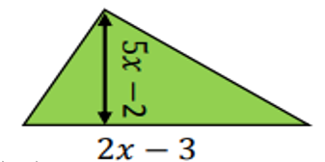 | Algebraic Solutions of Equations  - Solve 5x + 4 = 2x + 5  - Solve through factorising x² – 4x – 6 = 2  - Tom is 5 years older than Ben. Sam is double Ben’s age. The sum of their ages is 74. How old is Tom?  Fractions and Decimals  - 0.06 x 0.4  - 0.048 ÷ 0.006  - Find $\frac{5}{4}$ of £64  - In a class, $\frac{3}{5}$ of students are girls. Of these girls, $\frac{2}{3}$ wear glasses. What fraction of the class are girls who wear glasses?  Averages and Charts  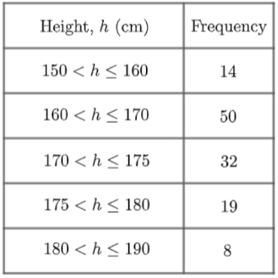  - Find and estimate for the mean:  - The mean of 4 numbers is 10. Three of the numbers are 4, 10 and 19. Find the value of the of the final number. | Congruent and Similar Shapes  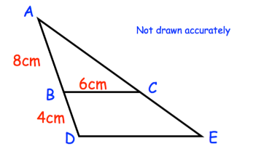  - Find missing length DE  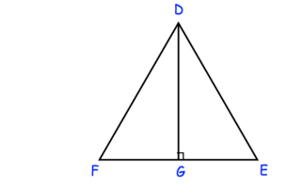  - DEF is an equilateral triangle.  G lies of EF.  DG is perpendicular to FE.  Prove DFG is congruent to DEG.  Pythagoras  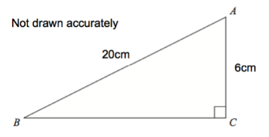  - Find length BC.  Trigonometry  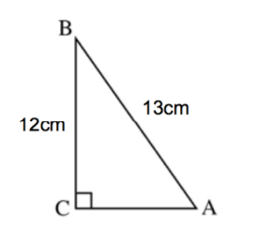  - Find angle BAC.  Proofs and Formulae  - Rearrange to make x the subject of the formula y = (2x + 3)² | Organising, Presenting and Analysing Data  - Parker wants to take a random sample of people who live in his street. Explain what is meant by a random sample and describe a method Parker could use to carry out his sample.  Bivariate Data  - Plot a scatter graph for ….  - Identify the outlier from your scatter graph.  - Draw a line of best fit onto your scatter graph.  - Estimate ….. from your line of best fit. Does this seem reliable?  Accuracy and Bounds  - 4.5cm is rounded to the nearest mm. Represent this in an error interval.  - A car is travelling at 50mph (to the nearest 10mph) for 3hours (to the nearest hour). What is the shortest distance the car could have travelled?  Mensuration  - The circumference of a circle is 32cm. What is the radius of the circle?  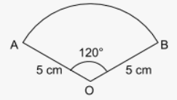  - Fine the perimeter of the below sector: | Simultaneous Equations  - Solve the following simultaneous equation:  4x + 3y = 20  3x + 5y = 24  - Two numbers have a sum of 20 and a difference of 8. By forming and solving two equations, find the values of the two numbers.  Percentage Change  - A car depreciates by 3.2% each year for 6 years. The car is valued at £4000 at the end of the 6th year. How much did it originally cost?  - Paul has two options for his savings. Either he can put it in a compound interest account of 4.2% per annum, or a simple interest account of 5% per annum. Where should he put his money if he wants to withdraw it in 4 years?  Bearings and Scale Drawings  - The bearing of a ship from a lighthouse is 055º. Workout the bearing of the lighthouse from the ship.  - A is 6km due north and C is 4.5km due east. Calculate the bearing of A from C. | Prisms  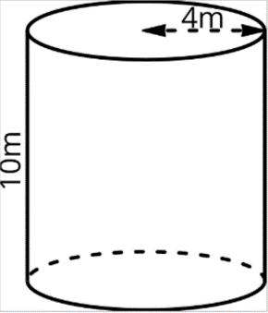  - Find the volume of the above cylinder.  - Find the surface area of the above cylinder.  Probability  - Laura observed 20 cars and found that 3 of them were blue. If Laura observed another 100 cars, how many would be expected to not be blue?  - At a restaurant there are 3 options for starter, 3 for main and 4 for dessert. Sam would like a 2-course meal. How many possible meal combinations does he have?  - Paul asked the 30 students in his class if they liked tea and coffee. 10 said they liked tea, 15 said they liked coffee and 12 said they liked neither.  What is the probability a student chosen at random likes both tea and coffee?  Constructions and Loci  - Below is a rectangle ABCD. Find the region which is:  - Closer than 3cm from B.  - Closer to B than C.  - Closer the AB than BC.  2D and 3D Representations  - From the front elevation, side elevations and plan view of the shape, draw a sketch of the 3D shapes.  - From an image of the 3D shape draw the plans and elevations of the shape.
Assessment topics | Mini assessments of all topics | Mini assessments  End of term tests | Mini assessments of all topics | Mini assessments  End of term tests | Mini assessments of all topics | Mini assessments  End of term tests
Cross curricular links/Character Education | Indices and Standard Form  In science standard form is used when working with particularly large numbers (e.g. mass and distance) and small numbers (again mass and lengths).  Algebraic Manipulation  In science algebraic manipulation is used to rearrange key formulae. | Algebraic Solutions of Equations  In computing algebra is used to form equations that create graphics.  Data Collection and Sampling  Sampling and data collection methods are reviewed regularly in psychology.  Compound Units  Compound units are used frequently in physics. | Pythagoras and Trigonometry  In design, Pythagoras and trigonometry are used to measure distances and angles of elevation/depreciation. | Organising, Presenting and Analysing Data  The ability to organise, present and analyse data is used in multiple subjects. This includes looking at statistics in Geography, collecting data in Biology and analysing data in Business and Economics.  Fractions and Decimals  In Design Technology, fractions are used when working with materials, or when scaling up/down recipes. | Percentage Change  In Geography, percentage calculations are used to make comparisons, e.g., looking at rainfall or comparing changes in population sizes.  In Business and Economics, profit, loss, growth and decay are all represented as percentages.  Bearings and Scale Drawings  In Design Technology you must be able to work with scale drawings.  When working with maps in Geography, you must also be able to work with a scale. | Circles, Spheres and Pyramids  In Design Technology, working with area and volume will help when designing different objects and products.

