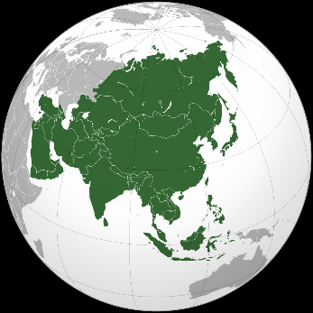
Year 8 Geography – Asia Summer Term – Key terms and priority
Introduction to Asia
- In relationship to the UK / USA
Location of specific countries in Asia
Asia (/ˈeɪʒə/ AY-zhə, AY-shə)

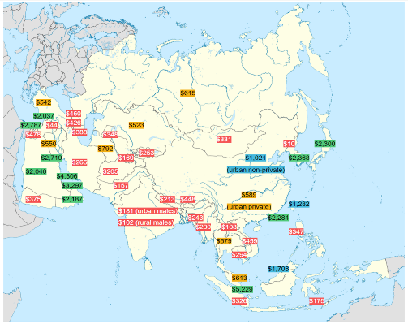
Difference in Asian countries - ɛkəˈnɒmɪks
- Climate – Siberia
- Religion – Buddhism
- Economics – China
- Physical Geography – Himalayas / Siberia / Rain forests
Economics – Net monthly salary
Bahrain US$4306 – North Korea US$10

Biomes (baɪ.oʊm/ BY-ohm)
What is a Biome?
Effects of a Biome on the landscape
Some specific biomes to study (Fauna / Flora)
- Tundra
- Taiga
- Temperate Forest
- Steppes
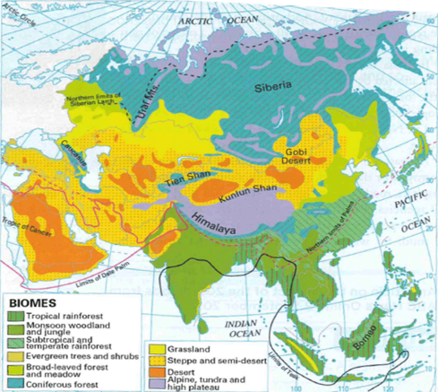

Megacities
- Definition
- Key words – Rural / Urban / Village / Population density
Sparsely + densely populated.
- What is lifelike in an Indian rural village
- Technology
- Infrastructure
- Health care
- Education
- Population



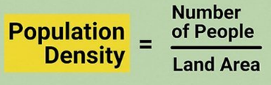

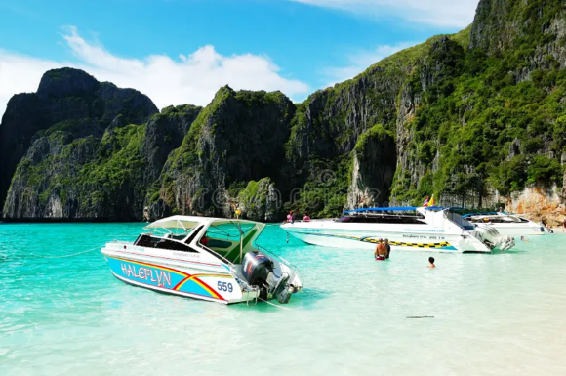
Tourism – Thailand / Maya Bay Kho Phi Phi Le pʰīː.pʰīː lē
- Location of Thailand to the world
- Location of Maya Bay to Thailand
- Features of the Bay
- Impact of tourism
- Solutions implemented
- Succes/failure of strategies

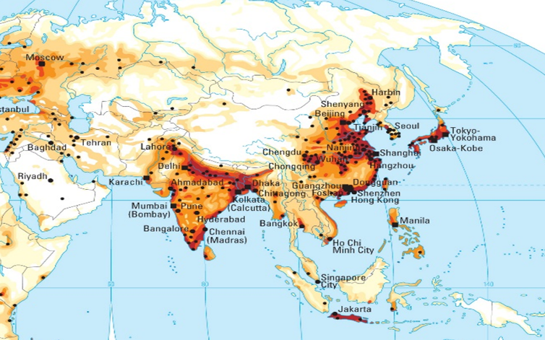
Future of Asia
- Diverse population
- Rising population numbers
- Location of the Asian population
- Issues with Japan’s aging population
- Solution to Japan’s dwindling population
Where do people live in Asia?

China (BRI or B&R)
- Economy
- Belt + Road initiative
- Chinas imports and exports
- Why is China growing so quickly
- Is the Belt + Road initiative good for the
world of China
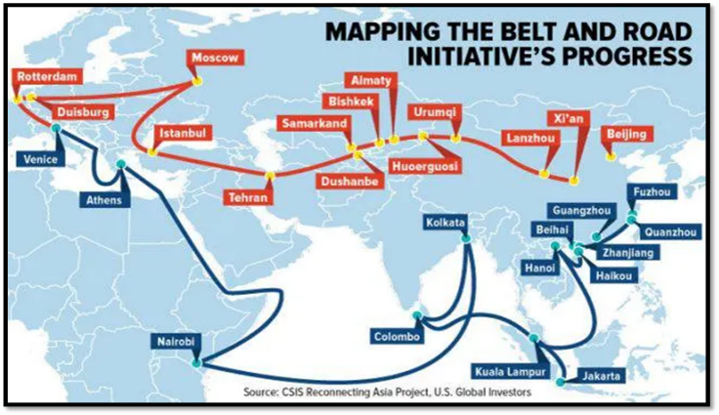

Links between Human and Physical features
- India
- Pakistan
- Panjab, Afghania, Kashmir, Sindh, and Baluchistan.
- Geographical features – Himalayas / Indus river
- Great divide of 1947
- What happened – Cost/Impact
- Disputed region - Kashmir
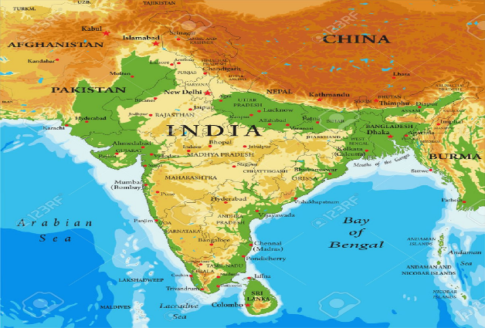

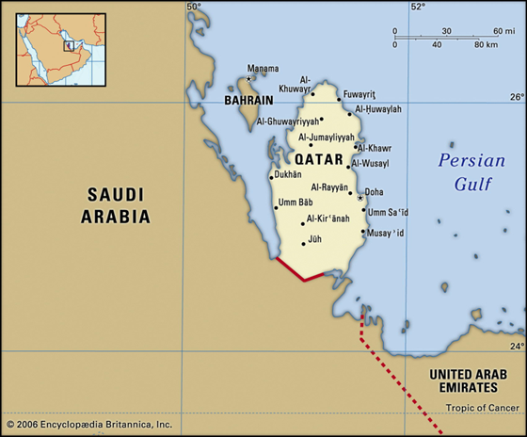
FIFA / HUMAN RIGHTS
- Where is Qatar
- What is Qatar like?
- World cup buildings + Human Rights
- Positive and negative points of the
FIFA World Cup in Qatar



