Year 8 Design & Technology Priority Keywords Biomimicry & Mechanisms

biomimicry  bi / o /mim / i / cry | Design and production of:  Materials, structures and systems that are modelled on and copy natural processes.  Applies ideas from nature to engineering, product design, and architecture.

linear motion  lin / e / ar mo / tion | Moves something:  In a straight line, in one direction.  e.g. a train moving down a track  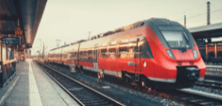

reciprocation  re / cip / ro / ca / tion | Repeated:  Up and down motion or back and forth motion in a straight line.  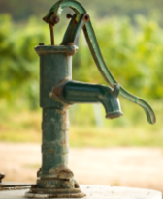  e.g. a piston or pump.

rotary  ro / tar / y | Where something:  Moves around in a circle around a central point  e.g. a wheel or fan blades  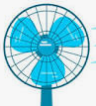    

oscillation  os / cil / la / tion | Curved backwards and forwards motion that:  Swings in an arc from a centre point.  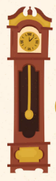  e.g. a swing or clock pendulum  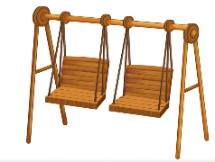

lever | A rigid rod:  Pivoted on a fixed axis called a fulcrum.  Used to change the direction of a force and to make the force larger or smaller.

mechanism  mech / an / ism | A part of a machine, or a set of parts that work together.

linkages  link / ag / es | Sets of connected parts that:  Work together to control movement in a product or mechanism.

