Year 7 Design & Technology Priority Keywords
UCD & Isometric
iterative design  it / er / a / tive de / sign | Process where you:  Continually build, test, evaluate and refine your ideas.  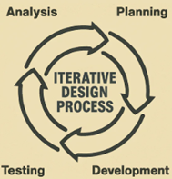

isometric  i / so / met / ric | A way of drawing a 3D object so  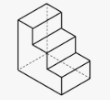  You can see its length, width, and height clearly in one view, so the object looks balanced and not stretched.  ‘Isometric’ means equal measure

crating | Technique used to:  Draw isometric boxes to help construct more complex 3D drawing.  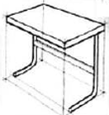  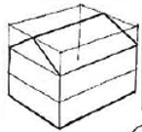

block shading | Drawing technique when you:  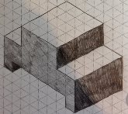  Shade areas in solid blocks of tone to show light, shadow, and depth on a drawing.  Shading used on flat surfaces

graduation shading  grad / u / a / tion | Shading that gradually changes  From light to dark to show smooth curves, light and depth on an object.  Shading used on curved surfaces

render  ren/ der | Add colour, shading, and texture to a drawing  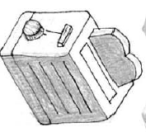  To show what the final product will look like.

thick/thin lines | Used together to make 3D drawings clearer, accurate and easier to read  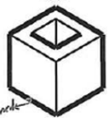  Thick lines - main outline  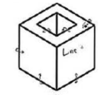  Thin lines – details,  construction lines, and  hidden features

