Year 7 Design & Technology Priority Keywords
Passive AMP
Art Deco | Design style from the 1920s and 1930’s  Characterised by its geometric shapes and streamlining.  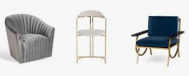

plywood  ply / wood | Manufactured board  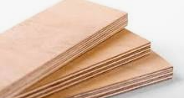  Made from thin layers, or "plies", of wood veneer that have been stacked and glued.

medium density fibreboard (MDF) | Engineered wood-based sheet material.  Mainly consisting of wood fibre particles bonded with resin and wax.  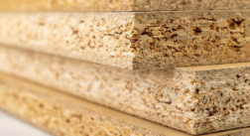

pine | Naturally grown soft wood  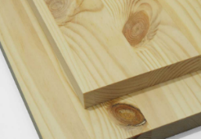  That is lightweight and used for construction and furniture.

softwoods | Obtained from conifer (evergreen) trees  Takes 30 years to mature, usually lighter and easier to work with.  ‘evergreen’ – retain their leaves all year round.

hardwoods | Obtained from deciduous trees that:  Lose their leaves in the autumn and winter.  Takes 100 years to mature.  ‘deciduous’ – means to fall off

