Year 7 Design & Technology Priority Keywords
Components
resistor  re / sis / tor | Regulates or limits  The flow of an electric current in an electrical circuit.  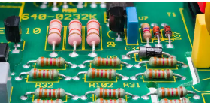

capacitor  ca / pac / i / tor | Electronic device that  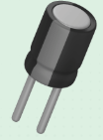  Stores electrical energy in an electric field.

piezo buzzer  pie/ zo | Electronic device that  Produces sound when voltage cause it to vibrate.  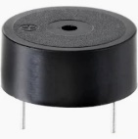  ‘piezoelectricity’ means ‘to squeeze or press’

slide switch | Mechanical electrical switch  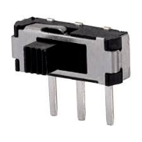  Controls the current flow to the circuit to turn the circuit on or off

555 timer micro-controller | Integrated circuit that:  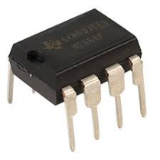  Controls timings in electronic circuits.

battery cable  bat / ter / y ca / ble | Wire:  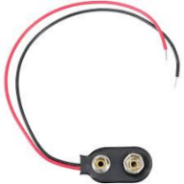  That connects the battery to the printed circuit board in an electric circuit.

9V battery  bat / ter / y | Electric battery:  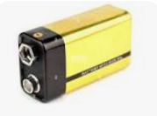  Supplies 9 Volts of electrical energy.

stylus  sty / lus | Small pen like copper wand:  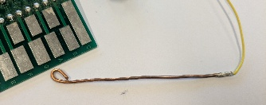  Used to play the stylophone instrument. It acts as a probe to contact the metal notes on the printed circuit board.

printed circuit board  cir / cuit | Mechanical base used to:  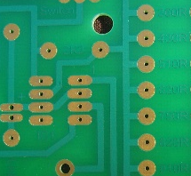  Hold and connect the components of an electric circuit.

track & pads | Connects, carries and joins:  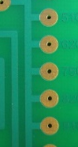  The track connects the components and carries the electricity around the circuit.  The pad is a small surface of copper to join the component to with solder.

Soldering
soldering iron  sol / der / ing | Electrical tool  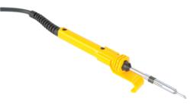  Used for melting solder to join the leg of the component to the pad on the printed circuit board.

Solder (Sn & Cu) | Fusible metal alloy  Used to join electrical components to printed circuit boards or wires  Sn – chemical symbol for tin  Cu – chemical symbol for copper

wire cutters | Tool for cutting wires  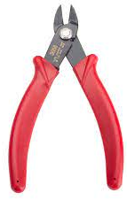

wire strippers | Handheld tool  Used to strip the electrical insulation from electric wires.  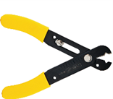

pliers  pli / ers | Small tool used for:  Holding or pulling small things like nails, or for cutting wire  

