Year 7 Maths Autumn 2 / Addition & Subtraction NP2
operations  op / er / a / tions | Rule for combining numbers.  Following are all operations  addition subtraction multiplication division

sum | Result of adding two or more numbers together  summand + summand = sum  25 + 75 = 100

difference  dif / fer / ence | Result of subtracting  The smaller value from the larger value to find the difference between two numbers.  minuend – subtrahend = difference

commutative  com / mu / ta / tive | When the order does not matter  Multiplication and addition are commutative operations.
  4 x 3 = 3 x 4 10 +7 = 7 + 10
number bonds  num / ber bonds | Pairs of numbers  That add up to a specific number  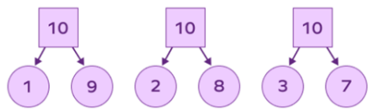  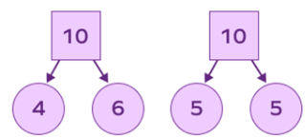

vector  vec/ tor | A representation of  Magnitude (size) and direction (postive/negative)  Vector represents the number 8  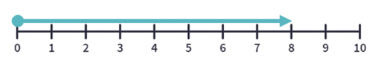

inverse operations  in / verse op / er / a / tions | Pairs of operations that undo each other.
  Operation | Inverse
  + | -
  - | +
  x | ÷
  ÷ | x

function  func / tion | Combination of  One or more operations

function machines  func / tion ma / chines | Relates an input to an output  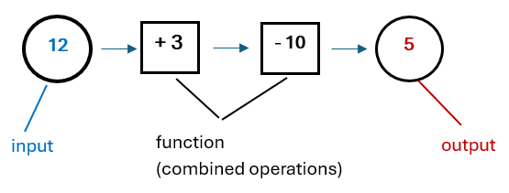

equality  e / qual / i / ty | State of being equal  Value of calculation has the same amount/value on the left and right side of equals’ sign  10 + 8 = 8 + 10

additive inverse  (zero pairs)  ad / di / tive in / verse | Number  When added to the original number gives the sum of zero.  -5 + 5 = 0  number additive inverse

fact families  fact fam / i / lies | Set of four related facts.  Created using the same three numbers e.g.  Addition and subtraction 2, 4, 6  2 + 4 = 6 6 – 2 = 4  4 + 2 = 6 6 – 4 = 2  Multiplication and division 3, 5, 15  3 x 5 = 15 15 ÷ 3 = 5  5 x 3 = 15 15 ÷ 5 = 3

perimeter  pe / rim / e / ter | Total distance around a shape.

rectilinear shapes  rec / ti / lin /e/ ar shapes | 2D Shape    With straight sides and right angles  

angle  an / gle | Amount of turn between  Two lines that meet at the same point.  Measured in degrees anywhere from 0° to 360°

mean | Average of a set of numbers  Add the values together then divide by the total number of values.    Dice thrown five times  4 5 1 1 6  Mean = 4 + 5 + 1 + 1 + 6 ÷ 5  17 ÷ 5 = 3.4

range | Measure of  How spread out the values are  Calculate by subtracting lowest value by highest value.  5 40 23 46 16  46 – 5 = 41

