Year 8 Geography Autumn Term Priority Key Terms Risky World

conservative plate boundary  con / ser / va / tive plate bound / ar / y | Tectonic plate margin  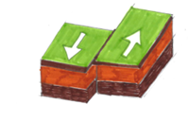  Where two tectonic plates slide past each other

constructive plate boundary  con / struc / tive plate bound / ar / y | Tectonic plate margin  Where rising magma adds new material to plates that are:  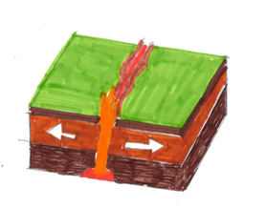  - diverging  or  - moving apart

destructive plate boundary  de / struc / tive plate bound / ar / y | Tectonic plate margin  Where two plates are:  - converging or coming together  - oceanic plate is subducted  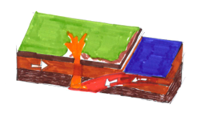  It can be linked with  violent earthquakes  explosive volcanoes

economic impact  ec / o / nom / ic im / pact | Effect  Of an event on the wealth of an:  - area  or  - community

hazard risk  haz / ard risk | Probability or chance  That a natural hazard may take place  e.g.  flooding volcanic eruption  earthquake tropical storm

immediate responses  im / me / di / ate re /spons / es | Reaction of people as  - Disaster happens  - Immediate aftermath

long term responses | Reactions that occur in  Weeks, months, and years after the event, for example  rebuilding/repairing properties  rebuilding/repairing transport links  restoring electricity, water, and gas

monitoring  mon / i / tor / ing | Recording physical changes  Help in forecasting when/where a natural hazard might strike, for example:  earthquake tremors around a volcano  satellite tracking of a tropical storm

natural hazard  nat / ur / al haz / ard | Natural event that  Threatens people or has the potential to cause:  damage destruction death  For example:  earthquake volcanic eruption  tropical storm flood

plate boundary  plate bound/ ar/ y | Boundary or margin  Between two tectonic plates

primary effects  pri / ma / ry ef / fects | Initial impact  On people and property as a direct result of a natural event  for example:  Buildings collapsing following an earthquake

secondary effects  sec / ond / ar / y ef / fects | After effects  Indirect impacts of a natural event, for example:  Fires if gas pipes were ruptured from the ground shaking.  Sometimes on a longer timescale

social impact  so / cial im / pact | Effect of an event  On the lives of people or community

tectonic hazard  tec / ton / ic haz / ard | Natural hazard  Caused by movement of tectonic plates.  (including volcanoes and earthquakes)

tectonic plate  tec / ton / ic plate | Rigid segment of Earth’s crust  Which can ‘float’ across heavier, semi-molton rock below.  Continental plates less dense but thick than oceanic plates

tsunami  tsu / na / mi | Long, high sea wave  Caused by an earthquake or volcanic eruption under the ocean

