Year 7 Geography Spring Term Priority Key Terms Rivers and Coasts

cliffs | Steep headland where:  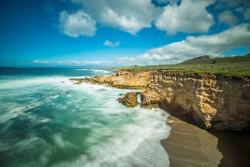  Constant erosion takes place at the base.  cliff

headland  head / land | More resistant rock that  Protrudes into the sea.  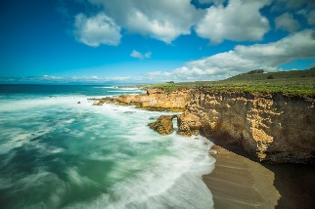  headland

bays | Softer rock  Form indentations in the land.  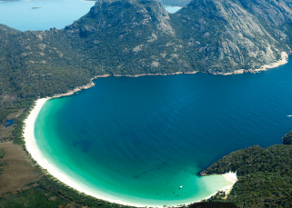

longshore drift | Movement of:  Beach sediment down a coastline in a zig-zag motion  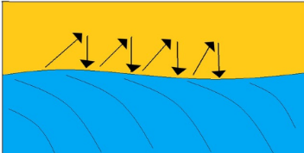
hydraulic action  hy / draul / ic ac / tion | Pressure of  Water being thrown at cliffs by:  Waves and compression of air in rock cracks

corrasion / abrasion  cor / ra / sion a / bra / sion | Result of  Sand and pebbles thrown against the cliff face, chipping off pieces of rock from the cliff.

corrosion / solution  cor / ra /sion so / lu / tion | Chemical reaction between  Chalk and limestone and salts and other acids in seawater.

attrition  at / tri / tion | Reduction in size and smoothing of  Pebbles on a beach as they  knock into and erode one another.

soft engineering  soft en / gi / neer/ ing | Coastal management strategies  Work with natural coastal processes.

hard engineering  hard en / gi / neer / ing | Coastal management strategies  Involve major construction work.  Often obtrusive

afforestation  af / for / est / a/ tion | Planting of trees  In the catchment area of a river to  - Intercept rainfall  - Slow down flow of water to river

infiltration  in / fil / tra / tion | Process of  Water entering soil or porous rocks

surface run-off  in / fil / tra / tion | Excess water  From rain or meltwater that flows over the land due to soil underneath being saturated.

saturation  sat / u / ra / tion | When soil is  Infiltrated to full capacity

V-shaped valley  shaped val / ley | Narrow valley with  - Steep sides  - Small river/tributary running through it

waterfall  wat / er / fall | Sudden drop in a river’s route  Resulting in:  Water falling vertically downwards until it reaches a lower level.

ox-bow lake | Small lake  Has been detached from the main river.  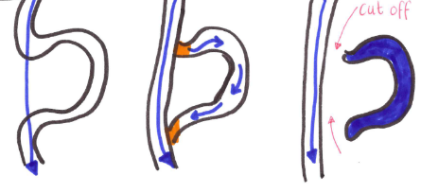

meander  me / an / der | Bend or curve along a river

flood plain  me / an / der | Flat area of land  On either side of a river  Made up of alluvium  deposits of clay, silt, sand

