Year 7 Geography Autumn Terms 1
Priority Key Terms Map Skills and World Geography
contour  con / tour | A line drawn on a map which:  Joins places of the same height  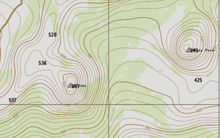

direction  di / rec / tion | Shown by:  Points of a compass.  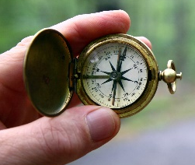

grid reference  grid ref / er / ence | Group of four or six figures used to:  Find a particular square of feature on a map.

key | Used to explain:  Symbols on maps and diagrams.
landform  land / form | A natural feature:  On Earth’s surface, such as  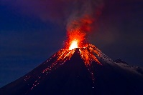  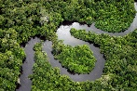  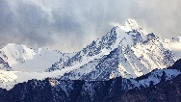  mountains rivers vocanoes

ordnance survey  ord / nance sur / vey | Official government organisation  Responsible for producing maps in the UK.

relief  re / lief | Shape  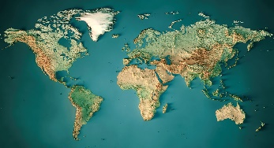  Of the land.

scale | Ratio of the distance:  On a map to the real distance.  e.g.  1 inch = 20 miles  1 cm = 13km

spot height  spot height | A point on a map  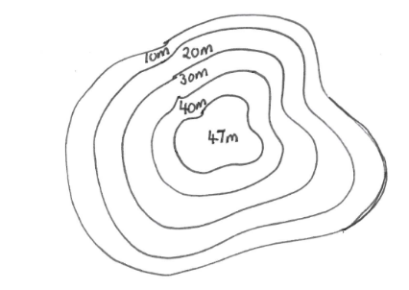  Showing height above sea level in metres

symbol | Simple drawing or sign used to:  Give information and save space on a map  

What a Wonderful World – Key Terms
landscape  land / scape | Visible features  Of an area of land.

continent  con / ti / nent | Huge area of land:  Separated from others by water or other natural features.  - Seven continents on Earth  - Together cover one third of the world  - Oceans cover other two thirds.

physical geography  phys / i / cal ge / og/ ra / phy | Study of natural features  Such as:  - landforms  - environment

human geography  hu / man ge / og/ ra / phy | Study of human features  Such as:  - towns  - cities

place | Physical and human characteristics  Give meaning to a location

process  pro / cess | Actions that  Shape and change human and physical environments

perspective  per / spec / tive | How different people  View and experience the world

interactions  in / ter / ac / tions | Connections between  - people  - places  - processes  - environments

sustainability  sus / tain / a / bil / i / ty | Meeting the needs of the present  Without comprising the ability of future generations.

environment  en / vi / ron / ment | Surroundings or conditions  A person, animal or plant lives or operates

tourism  tour/ ism | Travelling to  Another place or country for leisure or business.

erosion  e / ro / sion | Process  Soil and rock is removed from one area of Earth and transported elsewhere through:  Natural causes such as:  wind water ice

