Results 2018 Disadvantaged Pupils
Key Stage 4 Results 2018
Indicator | Year | Disadvantaged Pupils - National | Other Pupils National | The Piggott School Disadvantaged Pupils
Attainment 8 | 2017 | 38.6 | 50.5 | 41.13
 | 2018 | 38.2 | 50.6 | 53.26
Progress 8 | 2017 | -0.33 | 0.12 | +0.20
 | 2018 | -0.40 | 0.13 | +0.61
Key Stage4 | 2015 Results DP | 2016 Results DP | 2017 DP Results | National Other 2017 | 2018 DP Results
Progress 8 | -0.25 | +0.26 | +0.20 * Inc outliers | 0.1 | +0.61
Attainment 8 | 43.67 | 47.89 | 42.28 | 49 | 53.26
English and Maths Threshold 4+/5+ | 55%  N/A | 53%  N/A | 78/33 | 71/49 | 71/47
EBBac % gained | 0 | 12% | 12% | 28% | 29% ( Good ) 18% ( Strong )
EBBac Entries | 17% | 12% | 2= 24% |  | 35%
English % 4+ | 50% | 53% | 89% | 73% | 88%
Maths %4+ | 83% | 82% | 77% | 76% | 82%
English %5+ |  |  | 87 % | 55% | 65%
Maths %5+ |  |  | 33% | 55% | 65%
Attainment Maths | 5.25 | 9.47  (4.2) | 7.11 | 10 | 10.12
Attainment English | 4.67 | 9.68  (4.3) | 8.00 | 11 | 10.71

Attendance Data

 | Year 7 | Year 8 | Year 9 | Year 10 | Year 11
Pupil Premium | 93% | 92.19 | 91.14 | 95% | 91%
Not Pupil Premium | 97% | 96.62 | 96.40 | 96% | 96%

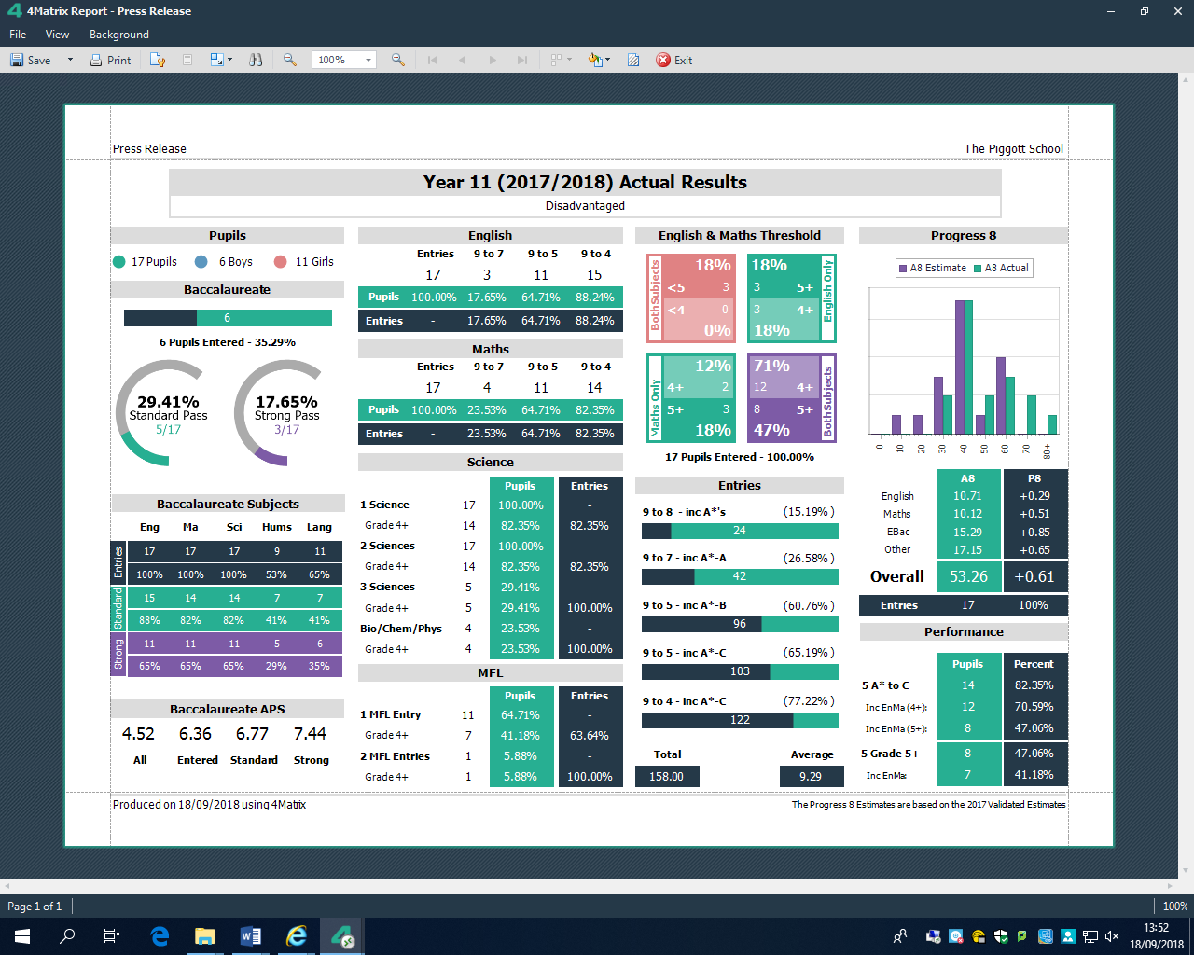
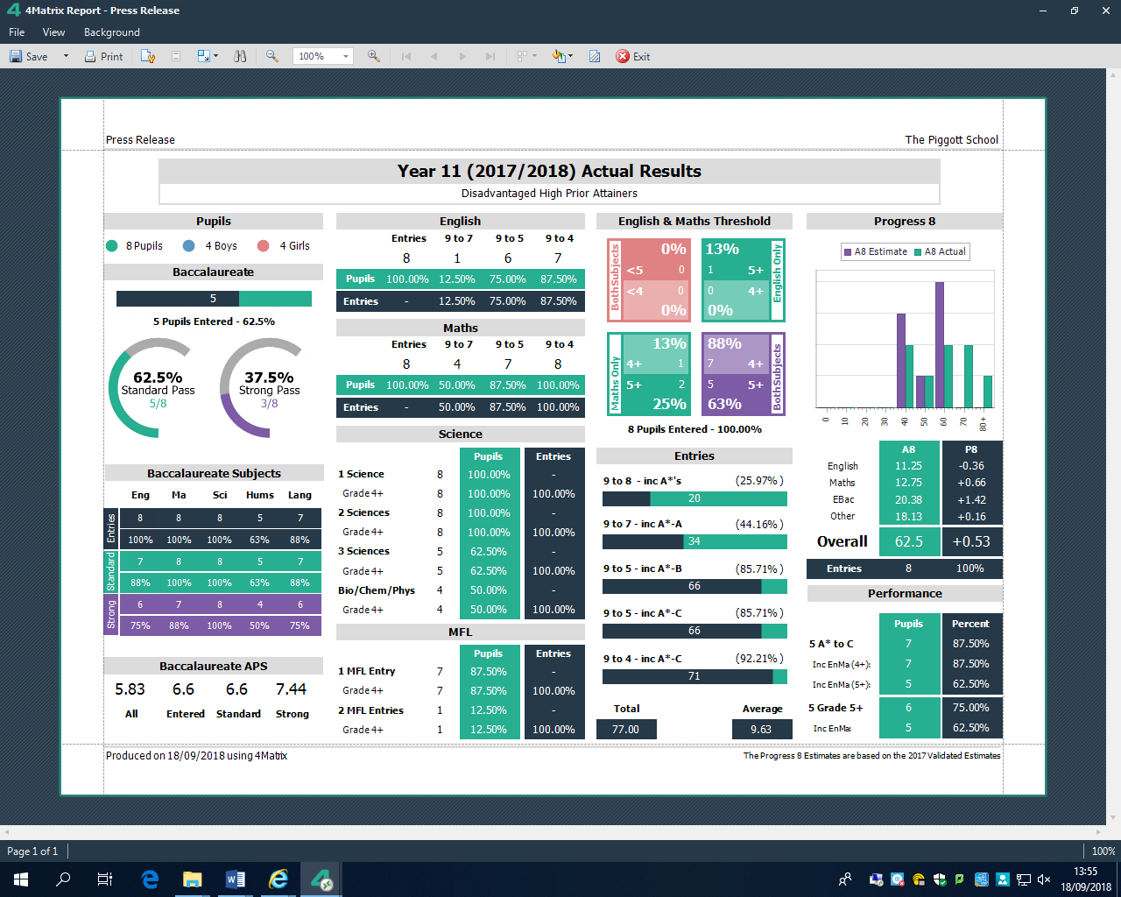
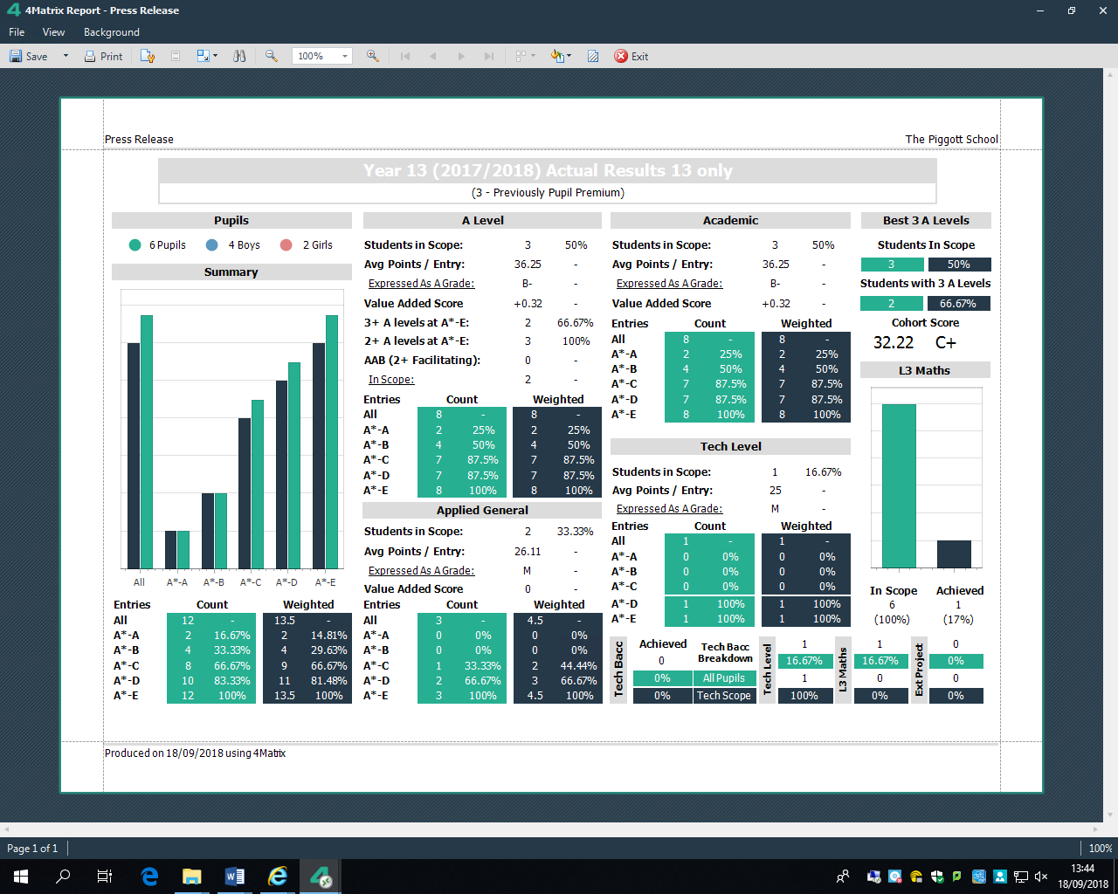
Year 13 Previously Disadvantaged

Destination KS4
Following excellent results –

8 Pupils remained at The Piggott School.

4 pupils joined other 6th forms

The remainder accepted college placements/ work placements

Key Stage 5

Value Added | 2014 | 2015 | 2016 | 2017 | 2018
Academic | -0.03 | -0.04 | +0.42 | +0.35 | +0.33
A Level | +0.01 | -0.02 | +0.55 | +0.35 | +0.33
Applied General | - | - | -0.39 | +0.61 | +0.28

Year 13 Destinations
3 moved onto University placements
3 gained employment /apprenticeships

Key Provisions for 2017 - 2018 Included

Addressing Basic Needs Removing Barriers to Attendance & Learning
  - Help with uniform costs
  - Breakfast scheme
  - Free lockers ( & padlocks)
  - Transport costs
  - Equipment ( pens, calculators – always available in the Green Room )

Addressing Emotional Barriers to Learning – Provision Included
  - Counselling - provided by ARC
  - Anxiety and Wellbeing guidance
  - Behaviour Support
  - Engagement Programmes – Reading Football Club
  - Mentoring – all Disadvantaged pupil s have a mentor these can be 6th formers, LSA, or Teaching staff
  - A Small bespoke nurture tutor group ( Green Room)

Removing Barriers to Inclusion
- Supported with Enrichment activities
- Supported with trips & overseas visits
- Provided Music Tuition
- Offered Samsung tablets to KS4 ( BYOD)
- Run reward schemes – Prom Passport – linked to yearbooks and Prom tickets
- Funded Gym memberships

Removing Academic Barriers we provided

- High quality 1st teaching with a focus on quality targeted feedback
- KS3 Literacy support – Accelerated Reader, 6th form subject mentors & Reading Buddies
- One-to-one or small group English tuition
- One-to-one or small group Mathematics tuition
- Homework Club KS3 & KS4
- Green room - offering bespoke timetables and co-ordinating mentoring and support in Key Stage Four - All year 11 pupils will be offered support via this facility
- Intervention Tutor Group
- Revision support group
- Intervention Parents Evenings
- Bespoke subject 121 including in Science and MFL
- After school support timetables for all year 11 pupils
- Revision packs
- Study Packs
- Numeracy support KS3 – from 6th form mentors
- English support programme
- Maths support Programme

To remove barriers of Low Aspiration and to promote the aspirations of the More Able

IAG (a range of support with developing aspiration and planning careers)
- Wellington College More able programmes - STEM/ Aspirational days
- Signposting to STEM pathways
- Signposting to Ebacc options – Including Mandarin
- Funding provided for trips and exchanges including China / Spain / France and Germany
- Double Language option pathways
- Transition group – intensive guidance
- 121 careers support form “in house” specialist
- Bespoke visits to local colleges

Key Aspects of our support
- Trainee Heads Of Year ( one per year group)
- Twice yearly surveys of disadvantaged pupils needs
- 3 weekly tracking of disadvantaged pupils progress in year 7/8
- Reformed GCSEs – the challenge of grade 5
- Department intervention and department representation at Intervention group
- Homework support in Key Stage 3 – to be run by KS3
- Bespoke curriculums – GCSE Photography in KS4
- Feedback – embedding the new PSHE/DIRT/FIT programme in years 7-10 aiming to build skills in metacognition and learning to learn skills.
- EAL support for all DP pupils - ( JC)

- Which provisions are most effective?

- High quality 1st teaching
- Bespoke plans with timely 121 or other intervention to support/remove barrier to progress
- English Support Plan
- Maths Support Plan
- Department Support plan
- Individual teacher Intervention

On-going analysis of the impact of each provision will enable decisions to be taken about how to spend the pupil premium most effectively. Provisions that have the greatest impact will be invested in more fully, while those that are not having as much impact will be reviewed and adapted to ensure they support student progress more effectively.

Impact & Action Plan Review for 2017 /18
Funding was £ 77, 495 est spend £83.000

See also the Spending Review Document 2018

Intervention | Details | Cost | Target group | Success Criteria | Impact | Evidence | Next steps
The Green Room  Green room /DP LSA support | In school facility for vulnerable students.  LSA’s to work in either the green room or embedded in key lesson | £18,000 from DP funding {£34,000 cost overall}  LSA costs per hour  LSA currently has  17 hours per fortnight | KS4 | Positive P8 Score  Attendance DP vs Non DP % ( Nat)  Positive P8 Score DP cohort  Progress data  No Permanent Exclusion  ( DP cohort)  Post 16 numbers in 6th form  Post 16 destinations  Better intervention and liaison GR /Depts | - All Year 11 mentored and supported  - All year 10 pupils had support via the Green Room  - Bespoke timetables tracked & coordinated  - Co-ordination of 1:1 support for English and Maths  - Intervention tutor group for revision period  - Mentoring from GR  - Co-ordination of DP support during revision period  - Equipment bank –  - To run the DP provision map  - engagement and making pupils “learn ready”  - Learn Ready – Counselling | See P8 score + .63  Retention to the 6th form  Of the 17 students – 8 remain at the Piggott on Level 3 courses – 4 others on A Level pathways at alternative 6th forms  3 have work related placements – remaining students at local colleges | To continue with  Key areas of Green Room Support  Hub for year 11 support  Manages year 11 PP revision  To continue with outreach top targeted individuals in year 10/9  To continue with early intervention including all key year 10 in timetabled GR Time from Sept 2018  To expand the mentoring provision offered by year 12 /13 to act as the main hub for this co-ordinate the allocation of both departmental 6th formers and mentoring 6th To track and to build a holistic menting support system. That is targeted and co-ordinated – to ensure all 6th form mentors are trained and have safeguarding training  Investigate Green Room LSA – One LSA has allocation for Maths Intervention in GR
Revision Support | To support pupils metacognition & ability to learn /revise. | £2000 | KS4 | Positive P8 score  %4+ GCSE E & M  %5+ GCSE E & M  No Neets - post 16  Build robustness Post 16  University placements for MA DP | Activities Days – e.g Exam Busters  Revision packs - HODs  English/Maths for 4/5 borderlines –  E learning support – HODs  Supervised Revision - GR  Support with revision timetables – GR  Intervention Evenings – All DP students – HOKS4  Afterschool DP department Intervention monitored via prom passport - NW  Exam booster sessions = Dept Reps /HODs  Walking Talking Mock/Mark programme HOKS4 | See P8 score +0.63.  Positive scores across Ebacc/open options  65%B 5+ English  65% 5+ Maths  88% 4+ English  82% 4 + Maths  71% 4 + E & M  47% 5+ E+M  18% 7+ English  18% 7+ Maths  29% EBACC 4 +  18% EBACC 5+ | To continue with the same revision programme – to meet Dept Reps October and plan intervention days and key materials required – to plan Earlier Intervention Eve - October
Trainee Heads of Year | 5 THOY to assist with the DPs in each cohort. | £7500  5 @£1,500 | KS3/4 | Attendance data  Inclusion data  Progress data  Parental attendance at parents evenings to match non DP | Duties include  Surveys one in Sept one at the end of the year  3 weekly tracking of progress & attendance  Behaviour tracking  Mentoring  Case studies on all pupils managed tracking provision  Tracking of inclusion /enrichment /trip  Support with basic needs  Attendance at parents evenings | Impact remains considerable in the engagement pupil and parent in day to day contact and support of basic needs. | To train new cohort of THOY  To build home – school relationships  To survey need each Sept and build support plan from there  To Mentor and represent the PP pupils
Curricular expansion – Extra English and maths teaching groups | Review the setting and curriculum for all year groups. | To be costed | KS34 | Curriculum models maximise student achievement. | Enable 121 in Dept or Groom  Small group work English and Maths  Data indicates high impact attainment and progress sig + comp national data.  GR to help co-ordinate support | See GCSE results for English and Maths above | To continue with small sets in KS3 /4 in English and maths
Out of hours 1-2-1 or 1-2-small tuition in Maths | DP receive personalised tuition in maths GCSE | £2500 | KS4/  KS3 | Positive Progress Grades  Attainment English /Maths  Ebacc | LSA 121  Green room 121 RG  Tutor Time Maths support  Teacher lead 121/small group  Additional use of Schools Direct and PGCE students  Maths to use additional staffing ( curricular expansion) to free up key individuals to provide 121 targeted intervention | This is difficult to monitor impact and and expensive to manage – higher impact is mostly from 6th formers or Dept LSA team or teaching interventions | Most 121 happens in hours and involves 6th form mentors and the LSA’s embedded in the Maths Dept.  Schools direct and PGCE to be offered121 after hours  Will Tutor Doctor have an impact on key students – PP+ ? It has been successful with LAC students
Out of hours 1-2-1 or 1-2-small tuition in English | DP receive personalised tuition in English language GCSE | £2500 | KS4/  KS3 | Students make 3 levels of progress/ achieve their attainment 8 grade. | Intervention organised & lead by English  121 from English LSA team  121 in Green room from overstaffing of English  English Dept to use additional staffing ( curricular expansion) to free up key individuals to provide 121 targeted intervention  Additional use of School Direct & PGCE students | Highest impact from LSA team | Most 121 happens in hours and involves the LSA’s embedded in the Maths Dept.  Schools direct and PGCE to be offered121 after hours  Overstaffing of English from Oct ½ term to be used to support Year11 English DP pupils
Year 12 Learning mentors | DP receive in class support from 6th Form Mentors | Non Costed | KS34 | Students achieve their target grades/ levels each year.  Year 12 to support pupils Learn Ready skills and build robustness and engagement | Department HODs and DP Department reps to identify year 12 pupils that can support key DP in lessons  No more than one session per fortnight for each year 12. | This Maths and Science mentors have had a high impact on progress a resilience of pupils – this was evident ion student feedback and results | To be expanded with Green room acting as a hub - see above
Mentoring  Teacher /LSA and Year 13 Peer mentoring | All DPs have access to a learning mentor  Non - contact time for Staff Member 1 period a fortnight  Staff Mentors KS3/4  LF/GP/NC/LK/SSc/NP | ARC training Day  Teaching mentors  1 hour per fortnight  £1000 towards overall costs | All KS | Transition report data positive Year 7  Inclusion data  Attendance Data  Improved Meta Cognition – learn to learn skills | Train and support the year 13 mentor team – currently around 20 trained mentors  Organise training on INSET day for year 13  AHOY to allocate mentors and liaise with CT in year 7/8  6th Form /Teacher or LSA allocated  Intervention group to review mentoring to look at scaffolding successful meetings.  Plan and structure 6th form topics/questions to support mentoring  AHOY to RAG all DP pupils according to need to prioritise support  A week each ½ term too be set aside to write up mentoring notes on Sims case /studies |  | To be continued as a key intervention
Basic Needs:  Equipment and Resources | DP are provided with essential equipment, resources and materials | £2500 | KS34 | Pupils can access all areas of the curriculum  Barriers to learning removed  Robustness and Resilience  Attendance and Inclusion  Equip marks | Barriers to learning removed  Assessment is that the processes involved in basic need support was unclear.  Tracking of spending needs to be firmed up | Eventual spend was 4,500 + impact is not measurable but evident in inclusion/attendance = uniform purchased transport costs funded – basic barriers to learning were removed DP pupils fitted in with their peers | Raise allocation  Review Uniform provision  THOY to support as required enabling pupils to attend and belong
Year 11 Reward Scheme | All year 11 pupils attendance in after school support to be tracked using Prom Passport - rewards for attendance could include/engagement include = Prom Ticket /yearbooks/Leavers Hoodies/Gym Membership | £1000 | KS4 | Incentivise learning & engagement  Attainment and progress data  Resilience in year 11  P8 /A8 | THOY to allocate prom passports plan daily interventions for all year 11  Attendance tracked using Prom Passport  Parents given written details on intervention plans AHOY | Provides incentive to attend after school support  Also removes any barriers of inclusion for the cohort | To be continued 2018
Learning Packs | Many Departments create learning packs of resources for DP pupils | £2000 | All | P8/A8  Incentivise learning  Remove barriers | This was £2,138 + and proved to be popular in departments and with pupils – English text books purchased/ revision guides purchased.  Primarily Year10/11 | Well received by DP pupils  A8 score  P8 Score | Funding to be increased  Dept Reps to be encouraged to consider 7-9 packs  English to issue Packs Year9-11  Maths to consider numeracy Mats
Curriculum Enrichment  activities, music tuition & trips to support curriculum needs – also includes food for Catering Food and nutrition  Enrichment  (EEF - Arts+2, Outdoor Adventure +3 Sports +2)  Our PP provision covers the costs of some school trips, enrichment activities and visits to broaden the life experiences of disadvantaged students | DP can apply for funding/support for enrichment activities, music tuition and school trips. | £2000  £12,0000 | KS34 | Increased engagement & achievement.  % attendance on trips and activities to be tracked  All KS3 DP to attend trip/visit  All KS3 DP to try a club/enrichment activity  KS4 all students to have appropriate curriculum support /enrichment  Remove aspirational barriers  Neet  100% of PP pupils to participate | - Funding/payment support provided for music lessons/residential trips and school trips ( FSM )  - Attendance on enrichment activities to be to be tracked by THOY  - Trip letters to contain DP/FSM statement |  | Music needs to be separated out in next years budget as it has grown so considerably  Over  Food has also expanded to be be separate item next year  In an affluent area it is essential that DP pupils feel a sense of belonging to the school. It would be easy for them to become isolated from their peers and the experiences that they have.
Careers Advice  IAAG -  ADVIZA  & In House Support | Extra time for PP students with the careers advisor | £1000 | KS4/KS5 | No NEETs at post 16  Post 18 - University placements/Apprentiships /work placements organised for all past DP | - To offer support in attendance at careers fairs  - All DP seen more than once  - Support as required with college visits /University visits  - All post 16 seen by In house team& given support plans  - All attend in school careers ACT day  - Destinations tracked in KS4/KS5  - All Receive IAG  - Support via bursary with University Open Days | See post 18 destinations  See Post 16 Destinations  All had careers meetings | This provision will need to be reviewed as part of the changing careers provision requirement. learning  All Year11/11 hav e activities day  MA DP pupils identified and sent to Wellington College for relevant courses
Literacy  Bespoke timetable KS3  Accelerated Reader Scheme  Reading Buddies  English LSA Mentors | To close gaps in KS3  Literacy Intervention in year 7  All students in Years 7 & 8 and the low attainers in Year 9 have access to accelerated reader. PP funding covers part of this cost.  Year 7 intervention supported by English LSA team Year 10 work on a weekly basis with key year 7 students to listen to them read  Year 10 pupils work with Year 7 pupils with low reading ages to boost confidence and love of reading  The team work on 121 throughout the day /group work /literacy support as well as well as Tutor time 121 | £7,000 towards cost of £14,000  £1000 out of total spend £4000  LSA time | KS3 | Pupils access the curriculum  Reading ages rise  Removes barrier to learning across the curriculum  Increase in reading ages.  Increase in reading for pleasure.  Transition and Resilience for year 7 & Year 10 DP pupils who support if appropriate  The LSA team in English have a considerable impact on those DP pupils with low prior attainment and Scaled Scores significantly below 100. | - Pupils with low scaled scores/reading ages to have literacy support in intervention timetable created by limiting language options to 1 and releasing timetable time for literacy lessons  DP Pupils on Reading Buddies and AR show improved reading ages | AR results greater progress has been seen since change in staffing  LSA team to run and manage Reading Buddies 2018 | Small group to continue with support from embedded team of LSA s  Morning Intervention to continue – including Reading Buddies as well as 121 with the LSA team  The school to continue with AR  2018  LSA team to continue 2018  English also keen to set up Reading Group for year 7 Parents and pupils DP money to fund books in 2017/18
Counselling & Mental Health service  ARC  In House Support 121 wellbeing and Anxiety | Extended counselling provision for PP students  To build resilience in DP and try to make them “ready to Learn | £1000  £1000 – towards costs | KS345  KS345 | Priority service  Better mental health for all DPs  Attendance data  PA Data  Robustness at key times  Neet Data  Post 16 Destinations | ARC services purchased  In House provision is ongoing  SLT lead To track DP access and attendance at this support | 12/28 pupils seen regularly in 2016/17 DP  This is a keen early intervention service to build resilience/ offer support and encourage pupils to keep attending  ARC also train our Year 13 mentors | To continue 2018
Behaviour management  121 – Offered by External Support | Extended support for DPs with complex needs  To build resilience in DP and try to make them “ready to Learn” | £1000 contribution  1 | KS34 | Priority Service  Better mental health for all DP  Zero Perm Exclusion DP  Zero Fixed term Exclusion DP  Aim to resilience required to learn  GR to track W/unit data  Behaviour marks tracked by THOY | KTN to track DP access and attendance | 14 DP pupils were supported on a priority service last year | This service is a vital aspect of our support package for the most vulnerable pupils  To continue funding 2018  To continue to look for alternative support managed moves if required
Feedback loops &  Learning to learn  ( Metacognition and self-regulation )  PSHE | Whole staff focus on feedback loops integrating this into our everyday practice  Pupils are equipped with learning to learn and self-review skills | Non costed | KS345 | Developing staff professional skills.  Pupils are equipped with learning to learn and self-review skills | T&L group clear emphasis on good quality feedback to students  DIRT and FIT training for all staff at INSET T&L briefings  DIRT & FIT time embedded into curriculum in new PSHE curriculum  Self = review and mentoring built into PSHE programme | P8/ A8 both positive | Ongoing in house INSET programme
Homework monitoring | Whole staff focus on homework setting, completion, marking, feedback. |  | KS345 | Appropriate, challenging homework is integral to every day at TPS.  Homework scrutinies show consistent practice. | Depts to set accessible homework tasks  Show my Homework purchased – which is much easier to work with than Frog |  | Staff reminded each year about assessable homework
Homework Club | Students have a facility to undertake homework at school | £3500pa | KS34 | Reduction in homework defaults leading to greater engagement and increases in results. | Homework is supervised after school in the Library | Homework remains an Issue for many Pp students – In Key Stage 4 the green room and reduced timetables offer support – the library and KS3 SEN support also offer alternatives | Departments to be encouraged to run their own supported homework clubs  Other support to continue
Bespoke Curriculum Interventions  121 subject support | Photography GCSE offered to ½ of DP Year 11 cohort to boost Progress and Engagement in a very small class size | Teaching time 5 hours a fortnight + set up  cost of course  £2000  +£5000  ( 5 hours per fortnight) | KS4 | Positive P8 scores in subjects offered  Bucket 3 scores improved  Improved points scores and post 16 options  Students have a positive school experience and make rapid progress – this will hopefully impact on other lessons as well as more positive behaviours | Pupils gain higher grade in new option than indicated by predations from final year 10 reports /year 10 PPE data -  fresh start for some disaffected by less successful option choices  Review P8 Scores of year 11  Identify pupils in need of points boost  Plan and Deliver ECDL to key Pupil  Plan and deliver Photography GCSE  Student wellbeing and self esteem is improved – re – engage with school in a more positive way | Photography Results –  100% 6+  VA to P8 moved it from +0.48 to +0.61  Pupils motivated self belief and aspirations improved- pupils chose to stay into 6th form or remain in main stream education / college  completed their education - it gave many confidence and self belief | Photography an option block for all now – the majority of PP students opt for it  New students to be identified in Year 11 cohort smaller as Year 11 Intervention Group ongong
Curriculum Enrichment  Enrichment ( general)  Activities & Trips | DP can apply for funding/support for enrichment activities, music tuition and school trips. | £12000 | KS34 | Increased engagement & achievement.  % attendance on trips and activities to be tracked  All KS3 DP to attend trip/visit  All KS3 DP to try a club/enrichment activity  KS4 all students to have appropriate curriculum support /enrichment  Remove aspirational barriers  Neet  100% of PP pupils to participate | - Funding/payment support provided for residential trips and school trips ( FSM )  - Attendance on enrichment activities to be to be tracked by THOY  - Trip letters to contain DP/FSM statement | 12, 000 spent  China, New York , Ski Trips, Tall Ships, Normandy, Holland,
Music Lessons | DP students to have access to Berkshire Maestro’s music lessons | £2,500 |  | To remove barrier to inclusion  To improve aspirations to support the more able  To increase assess to Music GCSE and beyond | - Music Department to identify and support DP students wishing to take music lessons  - This is not dependant on the taking the subject at GCSE it could be enrichment  - Pupils taking GCSE should have music lessons funded if required | £2,000 was spent on a variety of music lessons for 7 students as well as funding for instruments ona loan basis this enabled them to participate in choir, attend trips take GCSE Mucis. | To continue to fund as required
Ingredients for Catering | Ingredients ordered for DP pupils via weekly ASDA order | £300 |  | To remove barrier to inclusion | - Food technician to liaise with Teaching staff and students to purchase ingredients as required | To enable all students in all year to participate in Food Lessons To facilitate GCSE Food & Nut as a viable GCSe options for all DP students | To continue to fund as required
Exam Remark scheme | Borderline grades to be remarked for DP pupils | As required | KS4/5 | Level the playing field for DP pupils | Letter to go to all DP pupils to gain consent in advance for resits  However impact will need to be monitored regarding new rules on remarks | Although there was limited impact the change to remarks aa to reviews of marking made this initiative to level the playing field not viable. | To review marks each year – and assess on a case by case basis
Breakfast Scheme | PP students have daily allowance in canteen | £3000 | KS34 | Increase in attendance and engagement with learning.  Improved punctuality = pupils ready to learn | This is a growing area of demand – to be revived following survey results – pupils more happy to engage with support | This is a popular incentive and support mechanism to get students into school on time and fed so that they are ready to learn up to 16 students have participated in this | To continue to fund as required
Tracking Progress | 4 Matrix is used to track in year data from year 9-13  Data Manager tracks progress across subjects in KS3  To track Progress in Year 7 ( GL assessment PT maths and English Tests and to conclude the Proof of Progress) POP tests with year8  ALPS Connect to be cons8idred post 16 | £500 contribution | KS4./5  KS3 | Increase staff awareness of gap data at a classroom level  Increase accountability  To track E & M gap data from Year 7 | This remains key in identifying student progress across all year groups the KS3 changes to assessment will also help with tracking progress – GL learning tests in Maths and English give key indicators as to gaps upon entry and CAT testing also helps identify student strength and areas for development | To implement new KS3 tracking to see its impact in the robustness of in year KS3 data -  To stop 3 weekly RAG tracking – to support teacher wellbeing | To continue with 4 Matrix and implement new KS3 assessment To enhance us of GL learning transition tests in English and Maths
BYOD /Digital access | To continue to offer device to KS4 Students  To purchase suitable e learning packages  To equip the Green room departments with spare , loan laptops | £2000  Allocated  Issued according to need &  According to student demand  To be reviewed following survey of need in October review |  | To remove barriers of learning to enable pupils to access e learning activities in lessons  To support those with laptop concessions’ | Laptops provided on a loan basis to those with identified need | To run the programme in a more bespoke way – nit tablets for all. | To fund on a as required basis – especially to support SEN PP students with Lap Top exam concessions
EAL 121 | We have 7 EAL DP  All have been assessed and 121 offered in required  121 work with EAL specialist | Non costed | KS3/KS4 & KS5 | To remove language barriers  To ensure that progress is made at all levels to reflect ability  P8 & A8 scores | Support ongoing as required all have worked with EAl support
New for 2017/8
To implement the plan for each teacher to record their own interventions for each DP pupils that they teach these may be costed or may be a teaching strategy |  |  | KS3 &4 | This was set up in sims and enabled staff to identify all DP students – however its impact was not certain and it was time consuming for staff | Not continued
More Able Support |  | Costs embedded in Action Plan | KS3/4/5 | Wellington College courses for the more able  University Open day visits  &+ intervention and Walking talking mocks  More able Intervention Evening  Careers Support | Wellington College programmes now embedded – a number of students have participated in the scheme – we are hoping to get some entered for th e 5 year wheeler programme | To continue and to look to get additional students that are MA on long term programmes such as the Wheeler Programme | Funding for transport., taxis as required

- For a detailed cost breakdown please see Spending Review – 2018

